

**Team Members**

Angelo Coonghe | 180004566

Sanket Kanji Hirani | 150016252

**Supervisor**

Dr Fadi Fayez

Proposal for Developing a Mobile Application

Hot Topic in Software development

Table of Contents

Work Distribution 3

Chapter 1: Introduction 5

1.1 Background 5

1.2 Current Situation 5

1.3 Scope 5

Chapter 2: Project Charter 6

2.1 Research Question 6

2.2 Aims and Objectives 6

2.3 Project Measurable Organisational Value (MOV) 7

2.3.1 Desired Area of Impact 7

2.3.2 MOV Metrics 7

Chapter 3: Literature Review & Requirements Gathering 8

3.1 Application Reviews 8

3.1.1 MIT Student Canvas 8

3.1.2 National American University 9

3.1.3 Studydrive – The Student Platform 10

3.1.4 BRAINYOO Flashcard App 11

3.1.5 StudySmarter - Your learning app for university 12

3.1.6 AUC Mobile 13

3.2 Discussion 14

3.3 Comparison Table 15

3.4 Literature Review Summary 16

Chapter 4: Project Plan and Brief 16

4.1 Requirements Identification and Analysis 16

4.2 Design and Analysis 18

4.3 Risk Analysis and Mitigation 20

4.3.1 Time Constraints 20

4.3.2 Application Development Immaturity 20

4.3.3 Communication Risks 20

4.3.4 Requirements Inflation 21

4.3.5 Technological Failure 21

4.4 Project Methodology 23

4.5 Technologies and Resources Required 23

4.5.1 Android Studio 23

4.5.2 Google Drive 24

4.5.3 Office 365 and Google Docs 24

4.6 Project Schedule 24

4.6.1 Project Approval 24

4.6.2 Project Proposal 24

4.6.3 Application design, development and testing 24

4.6.4 Project report 25

4.7 Work Breakdown Structure 25

Chapter 5: Project Implementation 26

5.1 Planning 26

5.1.1 Use Case Diagram 26

5.1.2 Business Processes and Flow Charts 27

5.2 Design - Initial Designs (Wireframe) VS App Design 51

5.3 Software Testing 55

5.4 Project Analysis & Learning Curve 59

Conclusion 59

Appendices 60

Appendix A 60

Meeting Minutes 61

References 71

# Work Distribution

|  |  |
| --- | --- |
| Task | Team Member Responsible |
| *Introduction* | *Angelo* |
| *Current situation and scope* | *Angelo* |
| Research question | Sanket |
| Project aims, objectives and measurable organisational value | Sanket |
| *Application reviews (3.1.1 to 3.1.4)* | *Angelo* |
| Application reviews (3.1.5 and 3.1.6) | Sanket |
| *Application comparisons* | *Angelo* |
| *Literature discussion and literature review summary* | *Angelo* |
| *Requirements identification and analysis* | *Angelo* |
| *Application design and analysis* | *Angelo* |
| Risk analysis and mitigation | Sanket |
| Project Methodology | Sanket |
| *Project technologies and resources* | *Angelo* |
| Project Schedule and work breakdown structure | Sanket |
| Use Case Diagram | Angelo and Sanket |
| *Business processes* | *Angelo* |
| *Flow chart diagrams* | *Angelo* |
| *Initial designs and wireframes* | *Angelo* |
| Project analysis and learning curve | Sanket |
| *Conclusion* | *Angelo* |
| Coding UI and processes | Sanket |
| Software Testing | Sanket |
| Report designing and formatting | Sanket |
| References | Angelo and Sanket |

# Chapter 1: Introduction

## 1.1 Background

Being established in 1970, Manukau Institute of Technology is one of the largest , category 1 rated (highest possible education rating rated by the New Zealand Qualifications Authority) educational institutes in New Zealand (New Zealand Qualifications Authority, n.d.). Being a technical, vocational & professional education provider, Manukau Institute of Technology enrols roughly 14,000 students every year (Manukau Institute of Technology, 2018). Being an educational provider with high number of students, the institute has student’s portal & all other web-based tools to help the students (Student Life, n.d) but not an application. In the fast-moving world where everyone is getting most of their day to day tasks done on the go, being able to access resources on the go (mobile) is a mandatory requirement. This is where our idea of a Student Hub, an android mobile application to help students with their requirements and resource/knowledge sharing comes in.

## 1.2 Current Situation

Although there is a web-based communication medium available as mentioned above, the people who can contribute to a discussion is limited to only those who are enrolled in that course. Also accessing the website requires more steps and is more time consuming than simply opening an application on your mobile phone where you only tap an icon on your screen. Other limitations of the current situation are discussed in the literature review of the canvas mobile application that is discussed later in this report

## 1.3 Scope

Although the application can be developed for everyone at the institute that may include students, lecturers and staff, our focus on this project will only be students. Rather than setting a bigger scope with a short timeframe to complete the project, we have decided to limit the application registration and use only to the institute’s students, in other words for a user with “@manukaumail.com” email address. And we will only be developing an application for the Android operating system, leaving iOS & Windows for future development plans. Initially, we will be limiting our application to provide categories of only main educational categories provided by the institute such as Business, Digital Technologies, Tourism & etc (Manukau Institute of Technology, Areas of Study, n.d.). There will be no other categories other than study streams but for the future development plans, the application is expected to expand to other non-study categories such as RideShare and FlatMates.

And the Application will be called ‘MIT Hub’.

# Chapter 2: Project Charter

## 2.1 Research Question

A question that casually pops up when you analyse the current situation at Manukau Institute of Technology is that, “Is there an opportunity to facilitate better interaction and communication on the go for the Manukau Institute of Technology community?”. Yes, there is an opportunity, and this is where our project comes into play. With carefully thought out aims and objectives that cooperate with the mission and goals of Manukau Institute of Technology, this project can help resolve this question.

## 2.2 Aims and Objectives

Currently, the Manukau Institute of Technology students have a limitation in terms of sharing study related thoughts, ideas and resources with other fellow students. The institute does offer canvas that acts as the main hub for accessing any course related resources, however this is optimized for desktop and laptop use. It is also limited in terms of the communication capabilities such that any contributions to course discussions and blogs are restricted only to the current students enrolled to that course.

With this project, the main aim is to facilitate the students of Manukau Institute of Technology with better communication and interaction within the institute’s environment and enhance their student experience. The main objectives of the project are outlined below:

* Provide a mobile platform that allows students to share their knowledge, ideas or even ask for study advice or help from other students. This is going to be achieved by creating a mobile application that will allow any student of the institute to post a discussion topic or study question as well as having the ability to respond to any other discussions that have been posted by other students.
* Research on different features that can be added to the application to make it as user-friendly as possible while keeping all interactions and discussions smooth and effective. This will be done by comparing other similar mobile applications and selecting the features that will best suit our application.
* And finally develop an application based on our research findings.

## 2.3 Project Measurable Organisational Value (MOV)

The Measurable Organisational Value (MOV) of this project put in simple terms is the value that this project will provide for Manukau Institute of Technology and for this project to be valuable to the institute, this project’s measurable organisational values must cooperate with the goals and mission of the organisation (Alexandra, 2018).

### 2.3.1 Desired Area of Impact

Customers (students) – the goals of Manukau Institute of Technology are centred around improving student experience and satisfaction as well as their performance (Manukau Institute of Technology, Plans and Strategies, 2018). Our project will help improve student experience as access to resources, sharing ideas, seeking help and communicating with other students becomes easier and more convenient.

Strategic – the vision of Manukau Institute of Technology is to be recognised as the leading institute of technology in New Zealand (Manukau Institute of Technology, Plans and Strategies, 2018). Having a mobile application fits well with their vision as, in this modern era (the world of smartphones), everyone one wants the convenience of having access to everything at the tips of their fingers.

### 2.3.2 MOV Metrics

With the deployment of the MIT Hub application, Manukau Institute of Technology should receive a 15% - 20% increase in the number of positive reviews they receive from their student satisfaction surveys within one year.

In addition to that, the sharing of knowledge, better access to study resources and the increased interactions between the students is estimated to improve learning possibilities with an expected increase of students’ A grading by 10% in the next year.

# Chapter 3: Literature Review & Requirements Gathering

As we will be developing an Android application, in the literature review, we will be reviewing the current system in use at Manukau Institute of Technology and then investigate similar applications that are available on the Google Play Store.

## 3.1 Application Reviews

### 3.1.1 MIT Student Canvas

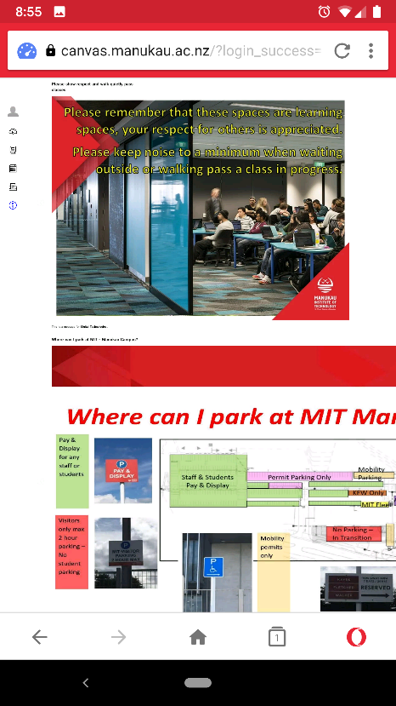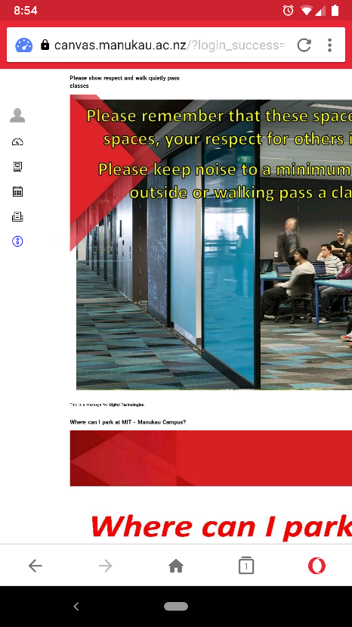

The current system at Manukau Institute of Technology is Canvas, where all the students can have discussions with the class they have enrolled to. This is a limitation of knowledge sharing where students cannot communicate outside their classroom. And as you can see in the screenshots above, when loading the canvas on mobile, it only displays half of the actual content as it is not very well optimized for mobile viewing and specially made for desktops. And, the loading time of the website is high due to the reason its focused mainly for desktops/laptops and not mobile phones.

Most of the notifications of discussions are sent through email which again is a long process to read, and then log-in to canvas and check the reply from fellow students. So, students need a better solution than a web canvas that is already in use at the institute and that is where MIT Hub comes in.

Now, we will be looking at different Android Applications that are similar to our idea of MIT Hub to get some ideas of functionalities and so on.

### 3.1.2 National American University

*by National American University* (National American University, 2018)

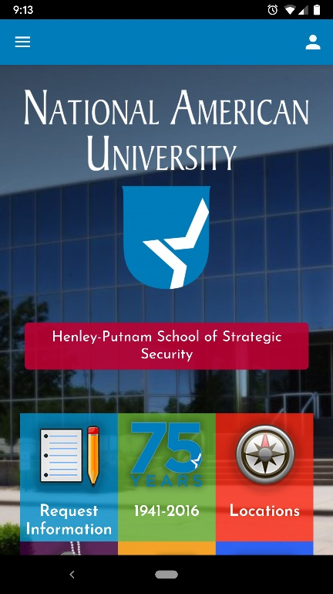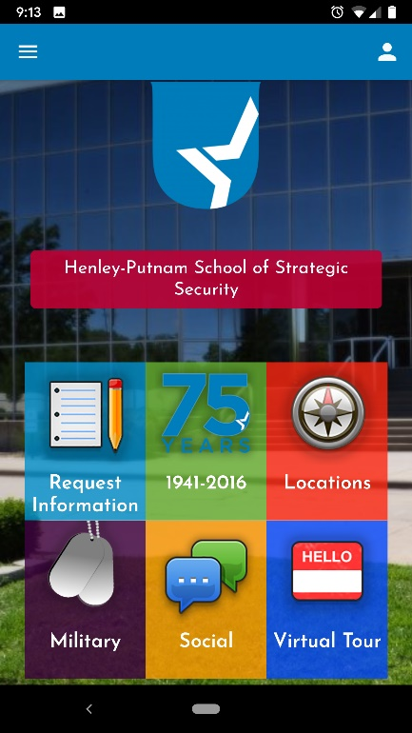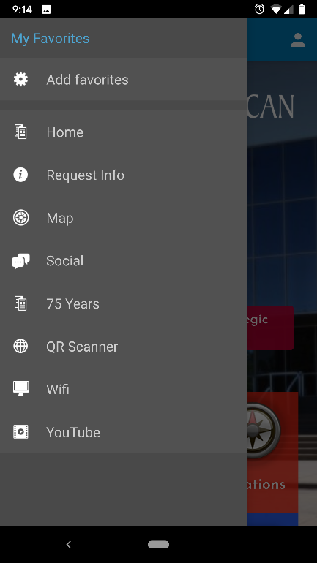

This application is developed for National American University with the purpose of students managing their account while getting more information about the university, facilities and following the social feeds of the university itself. The application does not offer any communication platform for students to share or discussions.

Although the design is simple and intuitive, it is not up to date with the current trend of material design. Navigation is on the good side and bad as the application has both side navigation on left and right along with middle tiles.

The application is mainly designed to communicate one-way information, from the University to students. But integration of 3rd party features like YouTube & QR code is beneficial for students.

### 3.1.3 Studydrive – The Student Platform

*by Studydrive GmbH* (Studydrive GmbH, 2019)

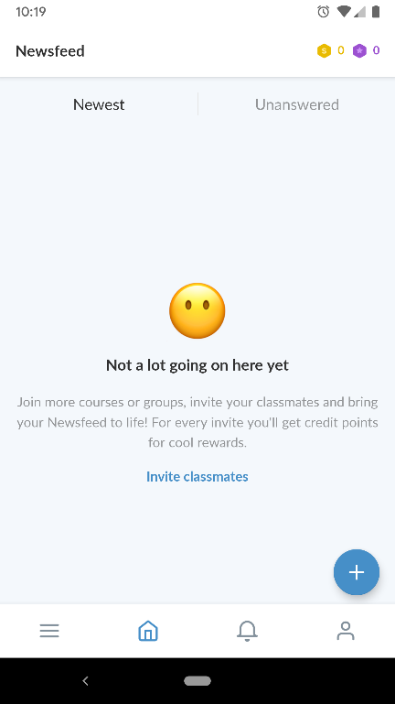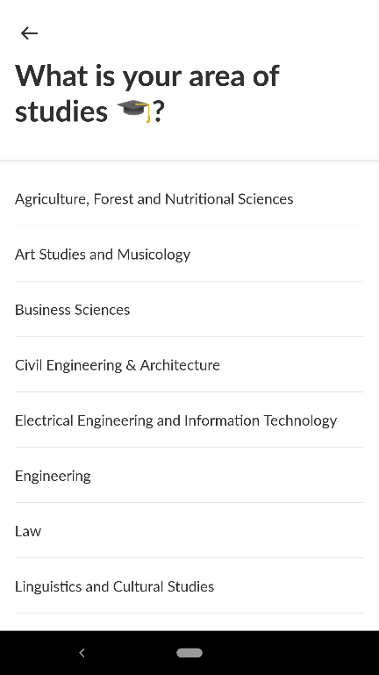

This application is an example of one of the best applications available on the Google Play Store. The design is very clean and exceptionally well thought out for students to make navigation simple with swipe gestures. Also, the interface is very clean and minimalistic which goes very easy on eyes to use the application for a long time effortlessly.

When it comes to functionality, the application is equally great with its design where the functionality is seamless with offering only what is required. And, the selection of categories when it comes to study modules and courses are good in terms of numbers. Also, the functionality of inviting friends is a great way to increase more downloads of the application itself.

Although this application is not focused to one specific university or institute, the ideas we can get from this is very useful and can be integrated into our idea. Most of the features and functionalities can be directly transferred across/adopted to our application.

### 3.1.4 BRAINYOO Flashcard App

*by Brainyoo Mobile Learning GmbH* (Brainyoo Mobile Learning GmbH, 2019)

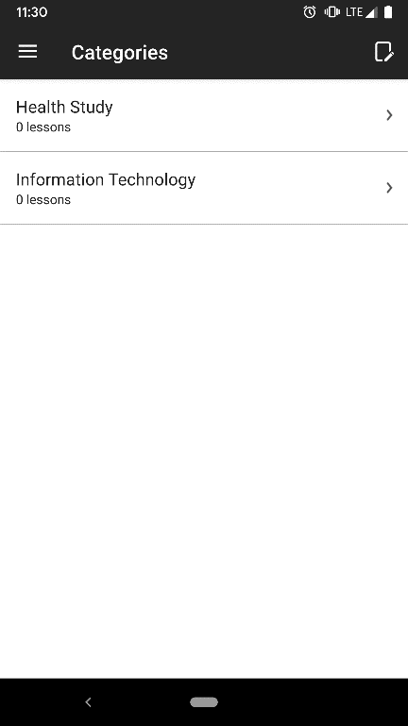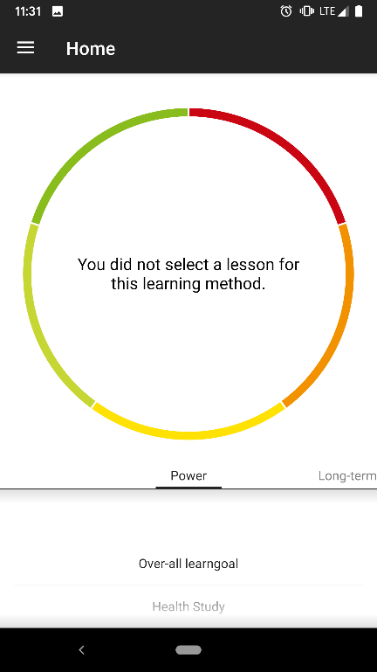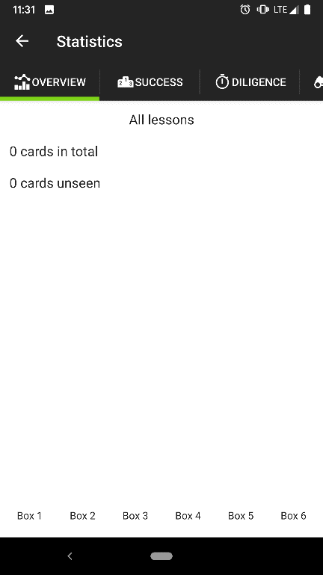

This is another great application available on the Google Play Store which helps students with their learning. The application itself is great but is heavily focused on self-learning rather than a group environment or knowledge sharing.

The design of this application is a great advantage being very simple and intuitive at the same with simple visual designs that makes the users interested in using the application without issues.

But when it comes to functionality, there is more to the application than what it looks. Specially with reports that offer how your learning process with the application. Also, the application’s functionality of demo that allows users to use the application to get a feel of it without even registering is a great advantage that will encourage users to like it even before they register and become actual users.

But it takes bit of timing figuring out the application as the navigation seems to be bit tricky and needs bit of training on how to use it for the first-time users.

### 3.1.5 StudySmarter - Your learning app for university

by StudySmarter (StudySmarter, 2019)

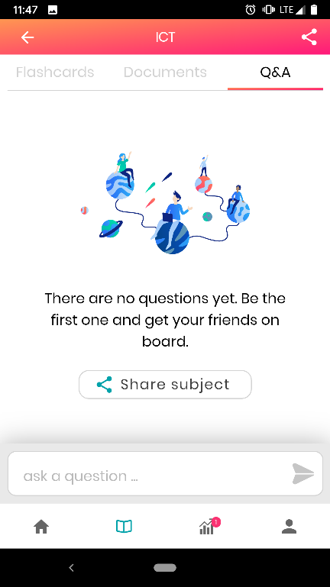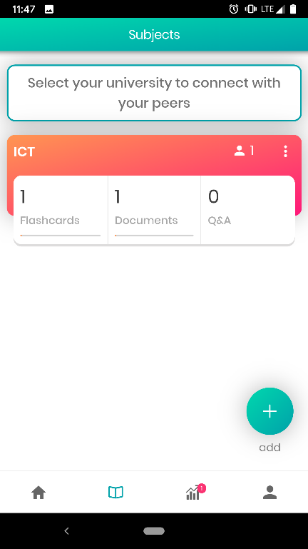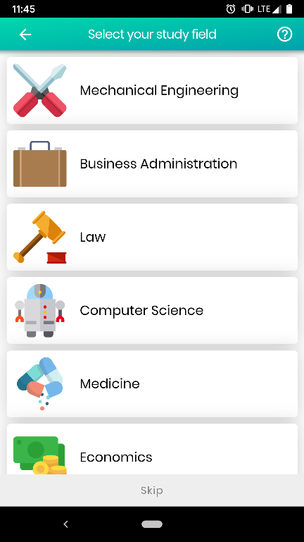

This is a well-designed application that maintains the current standards of industry designs. The application is more focused on the general society than to a specific institute or university therefore the features offered are much more generic.

The colour choice of the application is great at the same time being simple and therefore appealing to the users. Also, it has got a great cards’ design that makes it easy for users to navigate but still maintaining the simple and professional looking design.

The functionalities of the application match up to its design standards where the application offers a cloud for saving documents and image addition too, a unique feature that is not provided by the other similar applications. The application also offers share features which encourages social interaction between students.

### 3.1.6 AUC Mobile

*by The American University in Cairo* (The American University in Cairo, 2019)

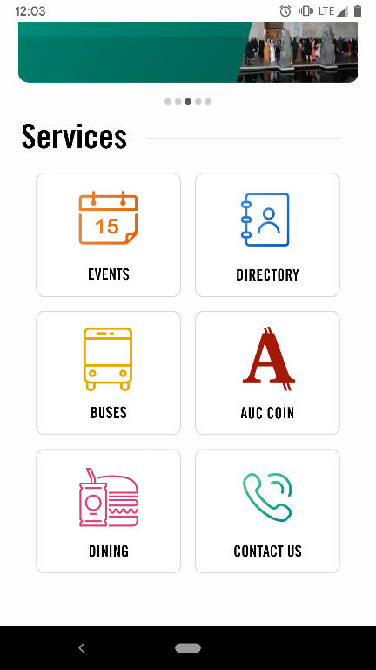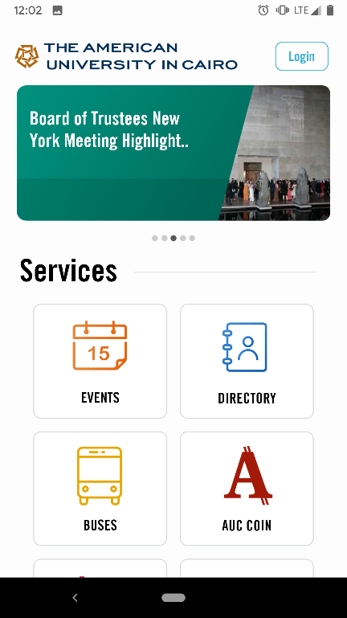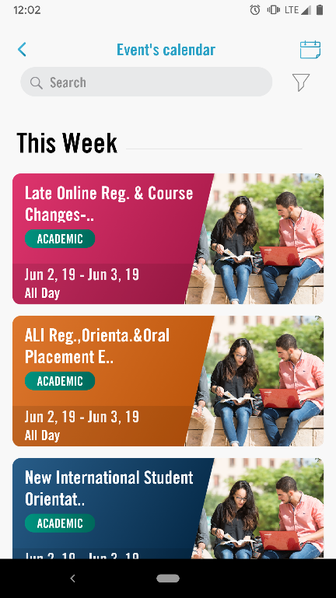

The final application we experienced is one that was published and is being used by an American university which is also focused mainly towards one-way communication where the application’s main goal is the university providing information and help to their students and no options for students to communicate back using the application.

The functionalities of the application are good, but the scope is very wide where it provides information from travelling, dining and much more. While the functionalities are specific to the university itself which is great, the effectiveness of using this application by students over widely used and more established travel applications is doubtful.

The application itself is very well and beautifully designed and very easy to use, providing access to guest users to get an idea of how it works even before registering.

## 3.2 Discussion

After reviewing the current system in place at MIT for students for knowledge sharing and communication which is Canvas and all the above applications that we reviewed, we have learnt that;

1. The current system at Manukau Institute of Technology is not as effective as having a mobile application that will be handy to use on the go.
2. While the current system offers most of the functionalities it is not mobile friendly or portable for students to stay in touch all the time which limits the use of this system.
3. There are few applications that excel in design and some in functionalities which we can adopt and integrate into our application which we believe will be highly useful for students – these functionalities might not be incorporated straight-away and could be in a future development plan for the application.
4. We also learnt that while keeping the design simple and clean the functionalities are what makes the application great when it comes to real-life use.

All the above applications are targeted for 3+ audience except one but this is mainly because these applications are educational thus making it safe for all users. While some applications have exceptionally great review and ratings, others lack in that and it could be because of the age of the applications and numbers users its focused on. If the applications are international like BRAINYOO & StudySMARTER, then the reach of the users are very high thus giving a great expose to application which will increase the reviews and ratings. But the applications with lower ratings and reviews are mainly developed for specific institution thus the users are limited but this is not to say the applications need a lot of improvements.

## 3.3 Comparison Table

|  |  |  |  |  |  |
| --- | --- | --- | --- | --- | --- |
| Application Name | National American University | Studydrive – The Student Platform | BRAINYOO Flashcard Application | StudySmarter - Your learning application for university | AUC Mobile |
| Developer | National American University | Studydrive GmbH | Brainyoo Mobile Learning GmbH | StudySmarter | The American University in Cairo |
| Target Age | 3+ | 12+ | 3+ | 3+ | 3+ |
| Rating | 3.6 | 4.5 | 4.3 | 4.2 | 4.3 |
| No. of Reviews | 19 | 259 | 2,590 | 156 | 16 |
| Downloads | 1,000+ | 10,000+ | 100,000+ | 50,000+ | 1,000+ |
| Design Trend | Semi Tiles | Material Design | Open Plain Design with graphs | Cards & Semi material | Tiles Design |
| Application Category | Education | Education | Education | Education | Education |

## 3.4 Literature Review Summary

|  |  |  |
| --- | --- | --- |
| Application Name | What’s Good? | What’s Bad? |
| National American University | 1. Simple & Intuitive 2. The functionality is relevant to university | 1. One-way communication focused. 2. Design is out of trend. |
| Studydrive – The Student Platform | 1. Clean & Simple Design 2. Functionality is exceptionally good 3. Easy to Navigate | 1. Not specific to one Institute or University |
| BRAINYOO Flashcard App | 1. Great design that is very simple | 1. Self-study centric application 2. Navigation is slightly complex |
| StudySmarter - Your learning app for university | 1. Exceptionally well-designed application 2. The functionalities are great | 1. Functionalities are too general |
| AUC Mobile | 1. Simple to use 2. Design is user friendly | 1. Offer too many categories 2. Focused on one-way communication |

# Chapter 4: Project Plan and Brief

## 4.1 Requirements Identification and Analysis

As this is a brand-new application that we will be developing for Manukau Institute of Technology, we will gather the ideas from the applications reviewed above in the ‘Literature Review’ Section. Also, we learnt all the possible categories from the institute website and Canvas along with other resources based on which our categories on the application will be showcased. During the development, we will be needing a database of some sort to integrate into the application to store student details when they register, as we do not have access to the current database used by Manukau Institute of technology to store their students’ data

To start with, we have drafted a design that will be our home page with categories that we think will be widely used on this application. For this, we use the trend of students register in New Zealand for specific streams of courses.

But all other categories will be based on the institute’s website where we have gathered all the categories of streams offered by Manukau Institute of Technology so the application can be limited only for those – at least for now.

To make the application easier for students to use, we will be using a clean and simple design that will be a material design to keep up with the current trend of mobile applications. Also, we will use very light colours which we learnt from the ‘Literature Review’ above that will be easy on students’ eyes as they need to be able to use mobile screens without having eye strains.

Another aspect of this application will be the navigation. This must be very simple, and students should be able to use it as soon as they register. So, we will be using simple navigational techniques such as swipe gesture which is also a current trend while also providing for an easy navigational design and feel to the application. However, we will focus on not having the application very cluttered with too many navigation options like the ‘National American University’ mobile application.

We will be drafting our designs based on our learning above and then analyse the features that will be suitable for development. Based on those results, we will then go ahead or make changes to the draft.

When it comes to functionalities, we will be limiting the application’s functionalities to only study categories for this project although we plan to expand it so other categories, outside studies also can be available. These categories may include RideSharing, FlatMates & so on.

As per our scope statement above, we will be limiting the application to only Android and there will not be an application for iOS or Windows OS although we might look into it in the future.

For students to be able to search, we will be creating a landing website with Google Indexing so it will make it easy when it comes to finding the application on the web.

## 4.2 Design and Analysis

We have discussed the designs based on our literature review, requirements gathering and analysis where a best possible option can be provided in our application and came-up with the initial draft designs.

Please note our designs provided here are only initial design drafts and subject to change based on development;

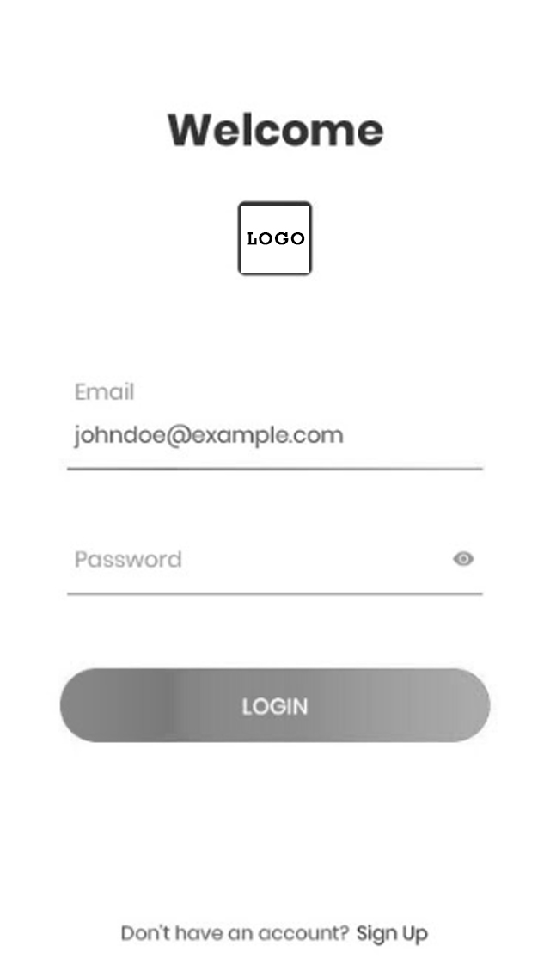

**Initial Screen for Users**

This is to keep the screen clean, simple and elegant; we chose to provide minimalistic design based on the ideas we took from other applications. Also, at this point we are not focused on any colours and provided the draft as a black and white draft image, but we are planning to use the same colour theme as the Manukau institute of Technology website, so the students quickly recognize the application as one of the institute’s. The purpose of this screen is simple as any log-in screen, Register and Log-in.

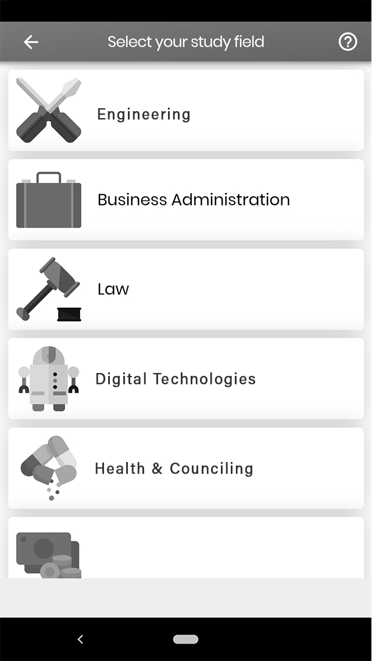

**2nd Screen**

This will be main screen or Home Page after sign-in for students where they can choose their category of study to join the conversation. Based on our development, we might look into loading the chosen category for registered users as default and then have an option to change category rather than having to choose category every single time. This will reduce one action for users to find what they are after.

And the other designs will follow similar material design as we go on developing the application. By doing this, we will be able to keep up with the design trend in the industry and provide the students with a simple and intuitive mobile application that looks professional and easy to use.

## 4.3 Risk Analysis and Mitigation

Uncertainties are always part of a project be it a large complex project or just a small simple one. Identifying these uncertainties early on and coming up with a well thought out plan to minimize the effects of these risks and possibly avoiding them can be the difference between the project succeeding or failing. Some of the risks associated with our project are outlined below:

### Time Constraints

We have been given just eight weeks to complete the project. This is very limited considering the amount of work that needs to be done to achieve the goals of our project. For this reason, we have identified and clearly defined a narrow scope for the project to ensure that all major targets are met. A detailed Gantt chart with a breakdown of the tasks has also been designed to track our progress and ensure that all the tasks are completed on time.

### Application Development Immaturity

Angelo is a member of the project team who is a networking student while I (Sanket) am just a student studying software development. This means that we lack the proper expertise to develop an application of a very high standard. In addition to that, it is even more likely that we will face major obstacles when developing the application. To manage the lack of experience, we will have to spend a lot of time researching to make sure that we make the right decisions and platform selections for our project as well frequently consulting with our lectures and any of our friends who have a better understanding and experience in the world of software development.

### Communication Risks

Communication plays a key role in every project and this project is no different. Since both Angelo and I (Sanket) have different backgrounds in terms of study fields and where we come from it is highly likely that we will be having different views and approaches to solving problems and working on any project task. This can sometimes lead to unnecessary confusion and conflicts which might delay our work on the project or even possibly cause the project to fail as we would be on different wavelengths. In order to stop this from happening, we will be holding regular team meeting as well as communicating as often as possible to clear up any confusions or misunderstandings.

### Requirements Inflation

This project requires a good amount of research to be done before starting to design and write the code for the application. This might lead to an increase in the number of ideas and functionalities that we could add to the application and. This is a very huge risk for the project as we have a strict timeframe and just two students working on the project meaning limited resources. Adding more and more functionalities to the application will surely make it better and more appealing, however this requires extra time that we cannot afford. One way of minimizing this risk is to stick to the scope we had identified earlier and get the main basic functionalities of our application working first. This will ensure that the project is completed on time and possibly if the general feel of the application is good, we can gradually introduce other features and constantly make improvements to the application.

### Technological Failure

Technological or hardware failures are not very likely to occur but there is a slight chance that a hardware or technological component would fail for example a storage device failing, laptop being stolen or even losing your internet connection. Any of these unfortunate events would lead to loss of project work and cause unnecessary delays. Backups are very important in this case, and an added precaution of both members having at least one copy of any project related document can negate this risk.

The table below summarises the risks and mitigation analysis done above:

|  |  |  |  |
| --- | --- | --- | --- |
| Risk | Probability Level | Threat Level | Mitigation |
| Scheduling Risk | High | High | * Have a limited scope * Create a detailed Gantt chart to plan and schedule our project and sticking to that plan |
| Application Development Immaturity | High | Very High | * Seeking for assistance from the lectures and other experienced developers * Doing lots of research |
| Communication Risks | Medium | Low | * Holding face to face team meetings as often as possible * Documenting all the discussions and tasks allocated during team meetings |
| Requirements Inflation | Medium | High | * Stick to the scope of the project * Get the main and basic functionalities of the application working first before adding any flair to the application |
| Technological Failure | Low | High | * Backing up all project related work on the cloud * Making sure all individual work is shared to ensure that at least one team member has a copy in case of a technological fault |

## 4.4 Project Methodology

After consulting with our supervisor Dr. Fadi Fayez, we realised that the waterfall model would not be best suitable for our project. The main reason why the waterfall model would not be the right choice for our project is because we have a very limited amount of time to complete this project. Therefore, for the development of the MIT Hub mobile application, we decided to go with Feature Driven Development. Feature Driven Development (FDD) is an agile software development process. This development methodology is a short iteration process that is built around five basic activities:

1. Develop an overall model
2. Build a features list
3. Plan by feature
4. Design by feature
5. Build by feature

These five steps are clearly visible during the development of our application where we create a use case diagram for our application, identify all the functionalities/features our application will provide and then followed by the iterative process of planning, designing and building feature by feature.

The main aim of this agile framework is to repeatedly deliver working, tangible software in a timely manner and this is what makes it most suitable to be used in the development of our application.

## 4.5 Technologies and Resources Required

### 4.5.1 Android Studio

Android studio is going to be a vital resource for the project. It is the official integrated development environment especially designed for the development of android applications (Wikipedia, Android Studio , 2019) and one that the project’s developer is familiar with, thus being the best choice of IDE (integrated development environment) for this project. Adding on to that, the major objective of this project is to develop an android application, highlighting the need of this technology.

Android studio does support a variety of different software programming languages, Java being the preferred option for this project.

### 4.5.2 Google Drive

Google drive is another major resource that will help organise, share and store any project documents. A shared folder has been created for this project and this is where all project resources such as the proposal report, teem meetings and presentations will be stored to ensure that both members of the project have access to these resources at all times as well as make contributions in real time. Another reason for the use of Google drive is to act as a backup for the documents to ensure that no work is lost in the case of an unexpected failure.

### 4.5.3 Office 365 and Google Docs

Google Docs is a very nice feature to have utilised in this project as this allows both members to work on one document at the same time. However, there is a limitation in terms of the designing and other features offered and this is where the Office 365 applications such as MS Word and MS PowerPoint will assist the project leader make the additional and final changes to these documents to make them more presentable, professional and appealing.

## 4.6 Project Schedule

Project scheduling plays a very important role in every project. Time constraints has been identified as a major risk and therefore the tasks of the project have been carefully planned to ensure that every task is given enough time and to make sure that the project is completed on time. The major tasks of the project are outlined below:

### 4.6.1 Project Approval

The breakdown of this major task is; formation of the team, brainstorming to come up with a project idea, sharing the project idea with our project supervisor and finalising the project idea.

### 4.6.2 Project Proposal

The subtasks include the process of project scheduling, identifying project objectives and goals, recognising project risks and how to avoid them, performing the literature review and finally documenting the project proposal.

### 4.6.3 Application design, development and testing

This is the point where the software methodology is integrated into the project and this is where the making of the application begins.

### 4.6.4 Project report

Creation of the final report that provides an insight of all the work done in this project.

Please refer to the Gantt chart in Appendix A for a more detailed version of the project schedule (major project milestones and a breakdown of all tasks within the project and the time frames in which they must be completed).

## 4.7 Work Breakdown Structure

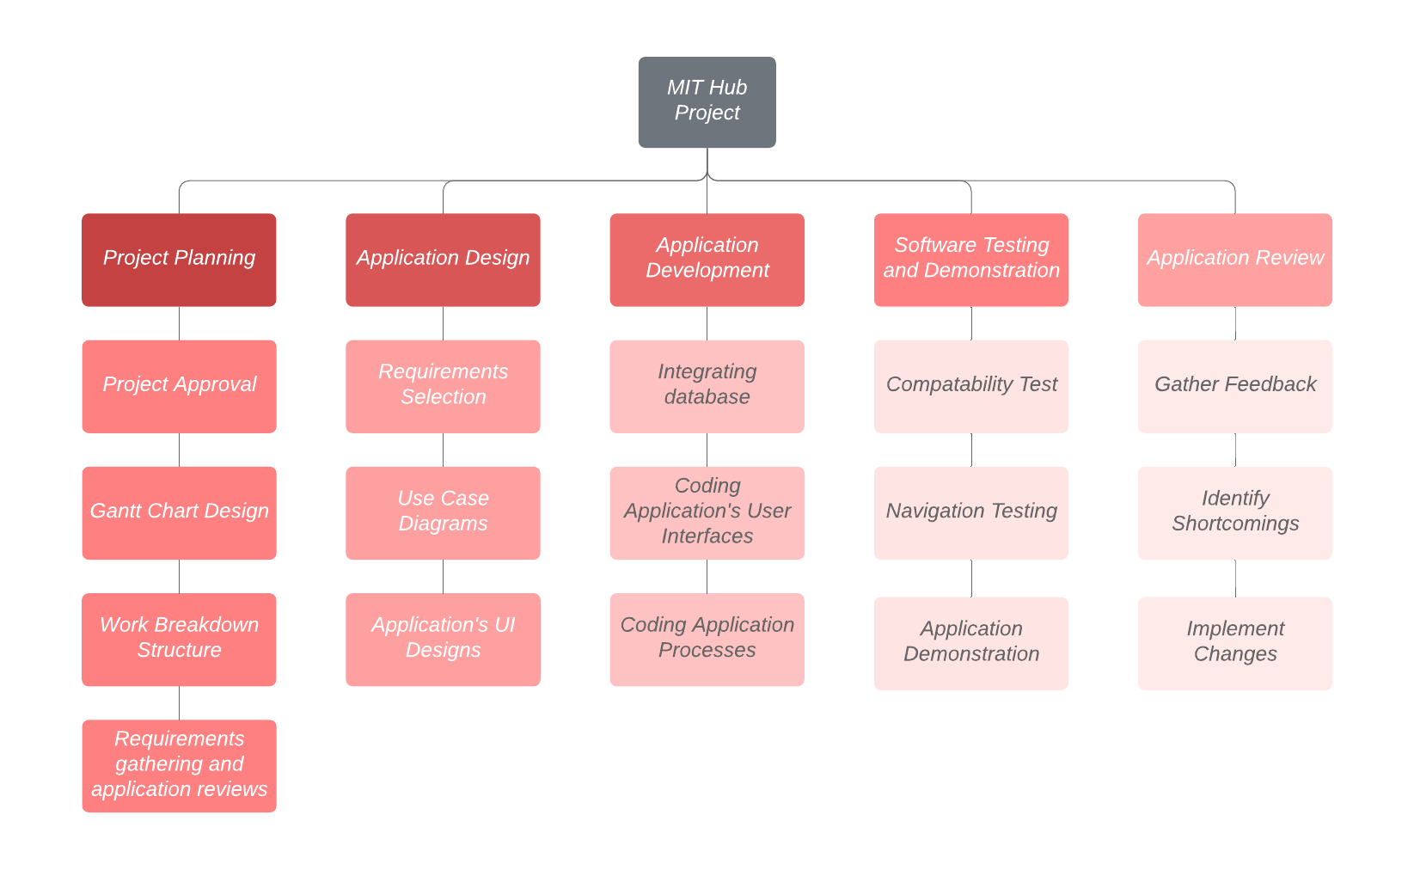Work breakdown structure is a key component in the planning and scheduling of a project. It helps breakdown the total scope of work to be done into smaller tasks, making the project more organised and manageable (Wikipedia, Work breakdown structure, 2019).

# Chapter 5: Project Implementation

## 5.1 Planning

### https://documents.lucidchart.com/documents/6217c99a-a66e-40fd-af37-ef7deda74441/pages/0_0?a=1950&x=97&y=-1&w=1502&h=1342&store=1&accept=image%2F*&auth=LCA%20c91fe6ab5570ed58f6d0835c52710accbd0a64b1-ts%3D15621183825.1.1 Use Case Diagram

### 5.1.2 Business Processes and Flow Charts

##### Register

|  |  |
| --- | --- |
| Use case | Register |
| Primary actor | MIT Student/Admins |
| Secondary actor | - |
| Pre-condition | Users must not be registered and does not exist in the database |
| Trigger | User opens the app and click register |
| Path | 1. System displays the registration page 2. User enters his/her details 3. System verifies email domain and send confirmation email 4. User clicks verification email link 5. User login using credentials |
| Post-conditions | User directed to Registration Confirmation Page |
| Alternative Path 1 | 1. User leaves text fields empty |
| Alternative Post-conditions | Error message displayed and user asked to enter the details again |
| Alternative Path 2 | * 1. User enters email that is not @manukaumail.com   2. System verifies and request to enter @manukaumail.com email address |
| Alternative Post-conditions | Error message displayed and user informed only emails ending with @manukaumail.com can register. |

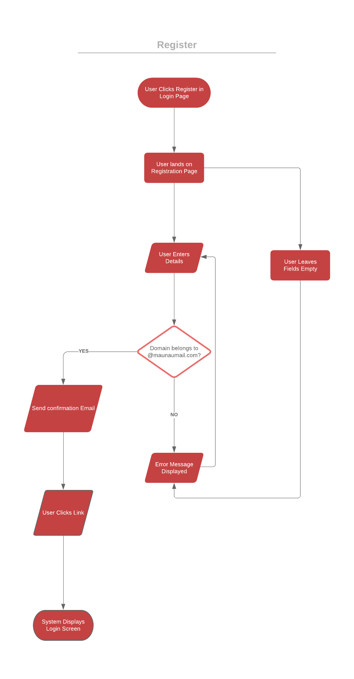

##### Login

|  |  |
| --- | --- |
| Use case | Login |
| Primary actor | MIT Student/Admins |
| Secondary actor | - |
| Pre-condition | Users must be registered and exist in the database |
| Trigger | User opens the app |
| Path | 1. System displays the login page 2. User enters the correct credentials 3. System verifies and a successful login |
| Post-conditions | User directed to the home page of the app |
| Alternative Path 1 | 1. User leave text fields empty |
| Alternative Post-conditions | Error message displayed and user asked to enter the credentials again |
| Alternative Path 2 | 1. User enters wrong credentials 2. System verifies and an unsuccessful match |
| Alternative Post-conditions | Error message displayed and user asked to enter the credentials again |

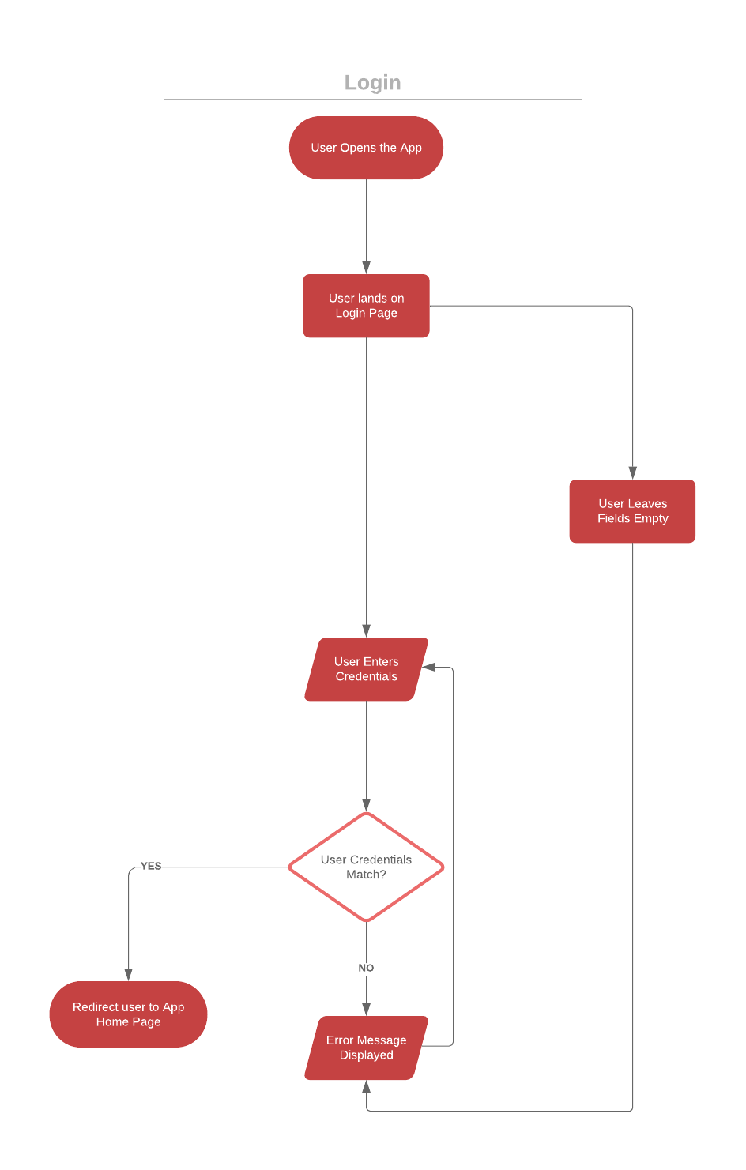

##### Update Details

|  |  |
| --- | --- |
| Use Case | Update Details |
| Primary actor | MIT Student/Admins |
| Secondary actor | - |
| Pre-condition | Users must be logged in to the app |
| Trigger | User Clicks Profile in Settings, within App |
| Path | 1. System displays the Profile page 2. User Updates his/her details 3. System verifies and saves details |
| Post-conditions | User directed to Settings Page |
| Alternative Path 1 | 1. User leaves screen without any changes |
| Alternative Post-conditions | No changes updated and user directed to home screen |
| Alternative Path 2 | 1. User enter details with characters not allowed 2. System verifies and request to enter permitted characters |
| Alternative Post-conditions | Error message displayed and user informed of characters allowed |

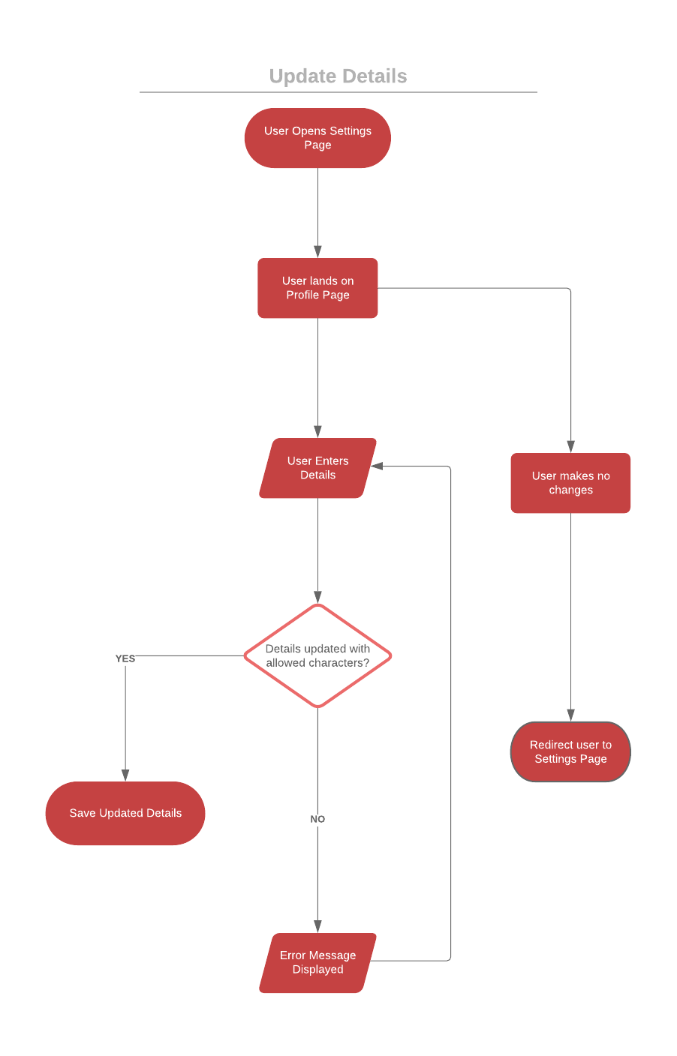

##### Post Discussion

|  |  |
| --- | --- |
| Use case | Post Discussion |
| Primary actor | MIT Student/Admins |
| Secondary actor | - |
| Pre-condition | Users must be logged in to the app |
| Trigger | User Clicks Post New Discussion Under a chosen Category |
| Path | 1. System displays New Discussion Page 2. User Enters discussion details 3. System verifies and posts in the category |
| Post-conditions | User directed to Category Page |
| Alternative Path 1 | 1. User leave page without changes |
| Alternative Post-conditions | No changes updated and user directed to Category Page |
| Alternative Path 2 | 1. User enter details with characters not allowed 2. System verifies and request to enter permitted characters |
| Alternative Post-conditions | Error message displayed and user informed of characters allowed |

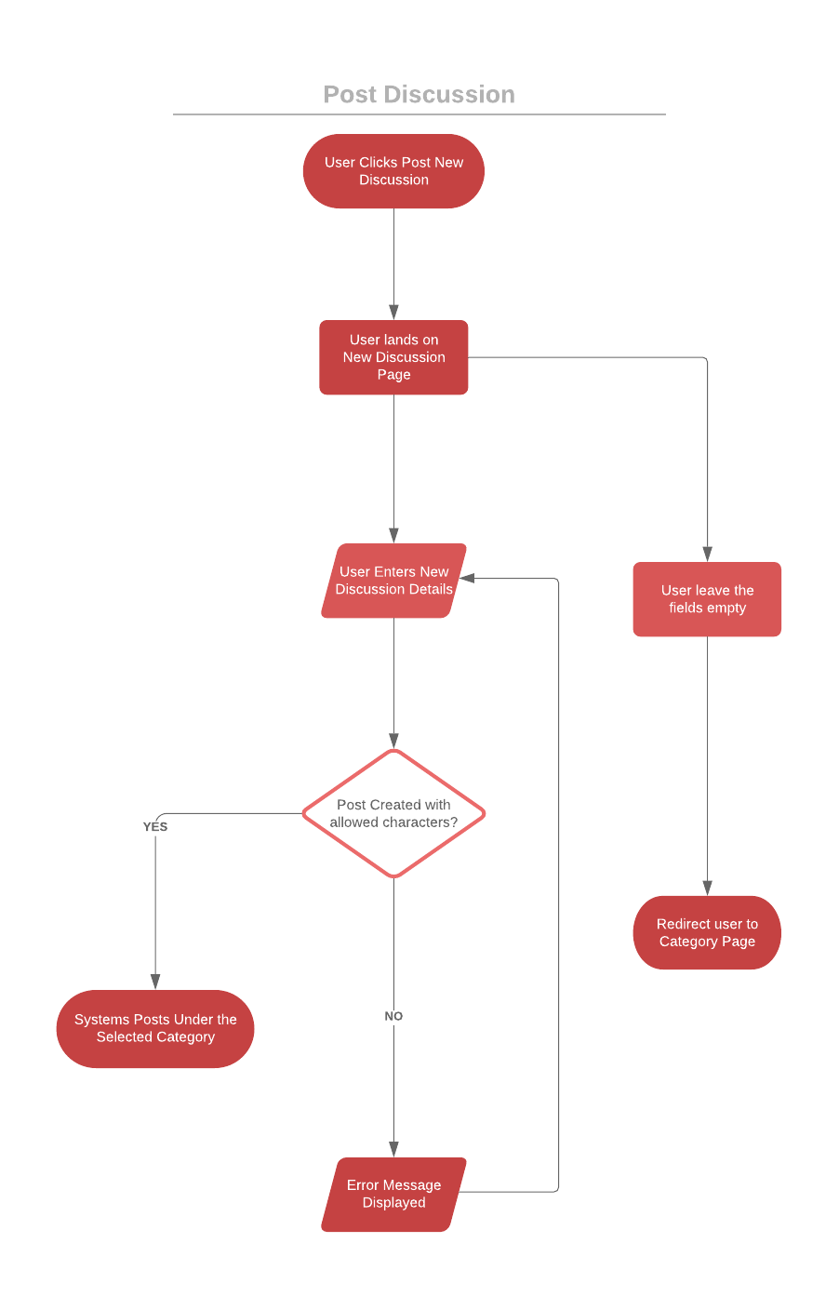

##### View Discussion

|  |  |
| --- | --- |
| Use case | View Discussion |
| Primary actor | MIT Student/Admins |
| Secondary actor | - |
| Pre-condition | User is inside category page |
| Trigger | Users select the discussion |
| Path | 1. System opens the discussion & displays |
| Post-conditions | Users stay in the discussions Page |
| Alternative Path 1 | 1. User selects the same discussion again |
| Alternative Post-conditions | System refreshes the discussion page for new updates/replies |

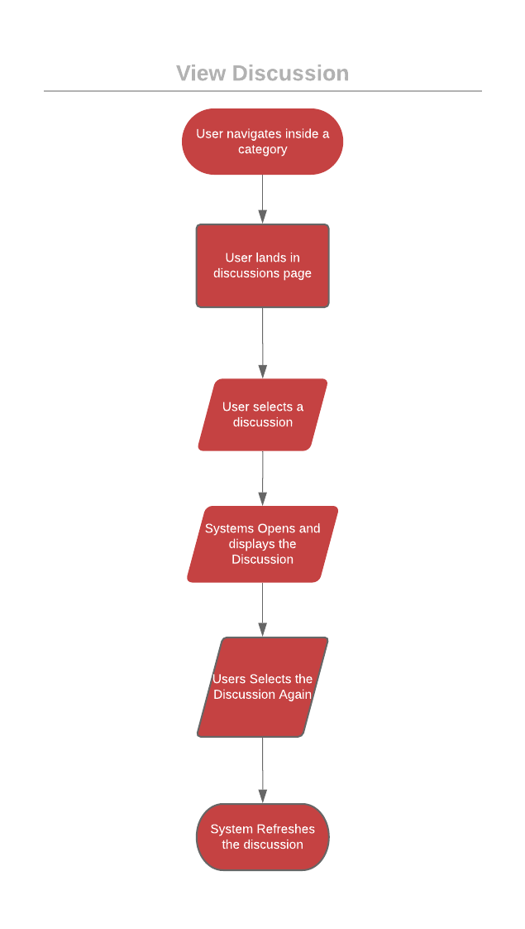

##### Up-Vote

|  |  |
| --- | --- |
| Use case | Up-Vote |
| Primary actor | MIT Student/Admins |
| Secondary actor | - |
| Pre-condition | User Selects a discussion from the category |
| Trigger | Users select up-vote icon under the discussion |
| Path | 1. System marks the discussion as upvoted 2. System increases the upvote number by 1 |
| Post-conditions | Users stay in the discussions Page |
| Alternative Path 1 | 1. User upvotes the same discussion |
| Alternative Post-conditions | System removes the upvote from the discussion |

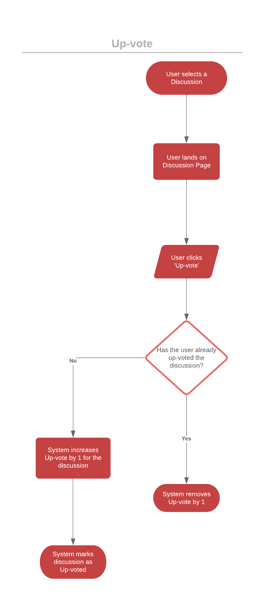

##### Down-Vote

|  |  |
| --- | --- |
| Use case | Down-Vote |
| Primary actor | MIT Student/Admins |
| Secondary actor | - |
| Pre-condition | User Selects a discussion from the category |
| Trigger | Users select down-vote icon under the discussion |
| Path | 1. System marks the discussion as downvoted 2. System decreases the downvote number by 1 |
| Post-conditions | Users stay in the discussions Page |
| Alternative Path 1 | 1. User downvotes the same discussion |
| Alternative Post-conditions | System removes the downvote from the discussion |

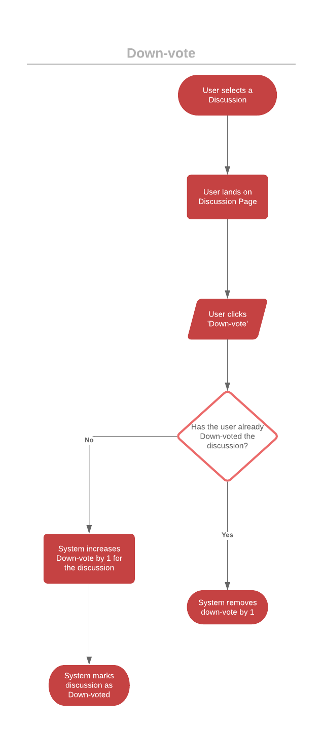

##### View Reply

|  |  |
| --- | --- |
| Use case | View Reply |
| Primary actor | MIT Student/Admins |
| Secondary actor | - |
| Pre-condition | User is inside discussion page |
| Trigger | Users select the reply |
| Path | 1. System opens the reply & displays |
| Post-conditions | Users stay in the reply Page with options to reply |
| Alternative Path 1 | 1. User selects the same reply again |
| Alternative Post-conditions | System refreshes the discussion page for new updates/replies |

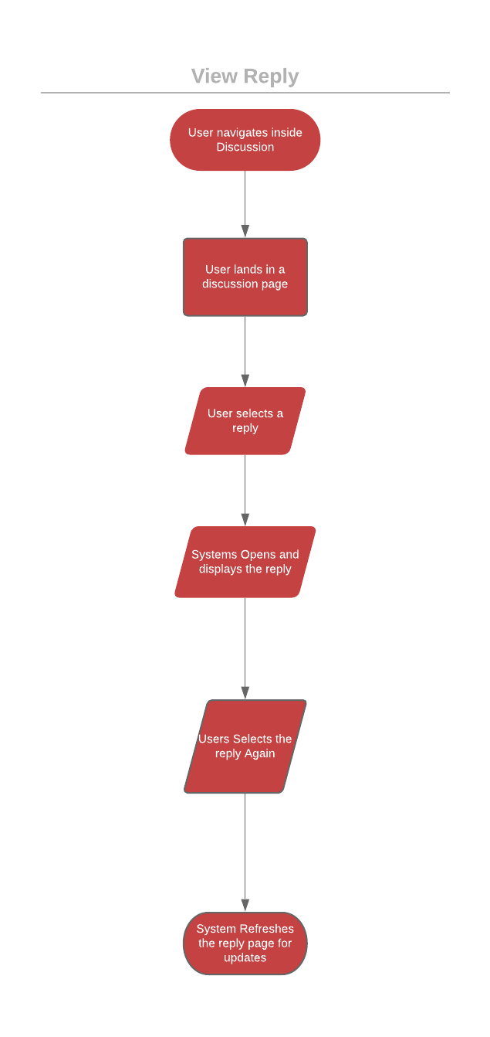

##### Reply to Discussion

|  |  |
| --- | --- |
| Login | Reply to Discussion |
| Primary actor | MIT Student/Admins |
| Secondary actor | - |
| Pre-condition | Users must be logged in to the app |
| Trigger | User Clicks Reply under Discussion Posted |
| Path | 1. System displays Reply Discussion Page 2. User Enters Reply details 3. System verifies and posts reply under discussion |
| Post-conditions | User stays in discussion Page |
| Alternative Path 1 | 1. User leave page without changes |
| Alternative Post-conditions | No changes updated and user stays in discussion Page |
| Alternative Path 2 | 1. User enter details with characters not allowed 2. System verifies and request user to enter permitted characters |
| Alternative Post-conditions | Error message displayed and user informed of characters allowed |

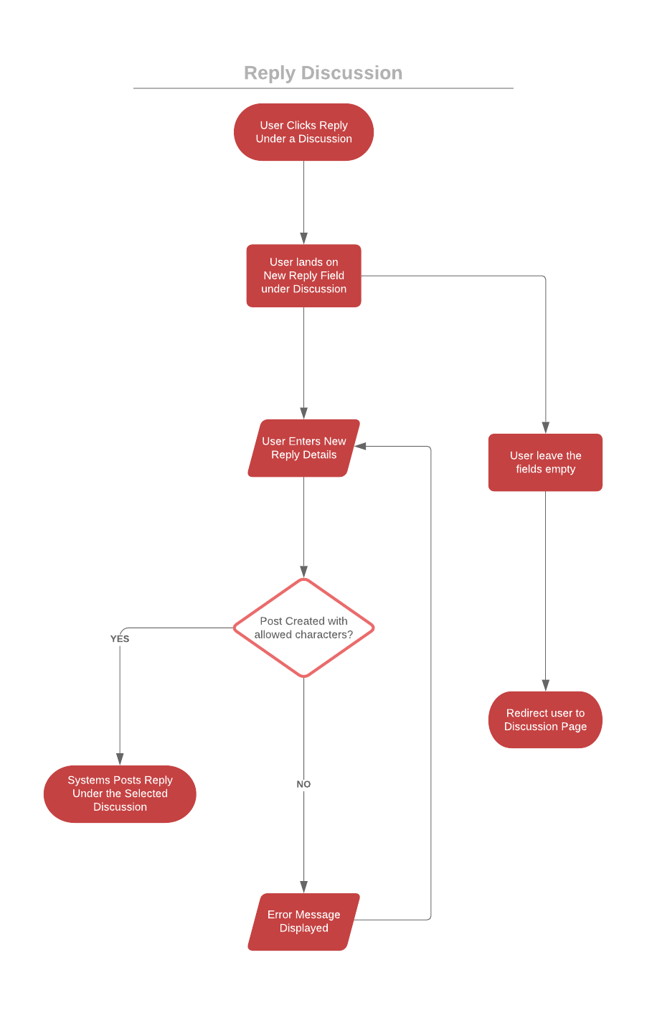

##### Search User

|  |  |
| --- | --- |
| Login | Search User |
| Primary actor | Admins |
| Secondary actor | - |
| Pre-condition | Admins must be logged in to the app |
| Trigger | Admins Click Search in Settings Page |
| Path | 1. System displays Search Page 2. Admins Enter Search Parameters 3. System searches and display results |
| Post-conditions | User directed to Settings Page |
| Alternative Path 1 | 1. User leave page without changes |
| Alternative Post-conditions | System displays all users |
| Alternative Path 2 | 1. enter details with characters not allowed 2. System verifies and request to enter permitted characters |
| Alternative Post-conditions | Error message displayed and user informed of characters allowed |

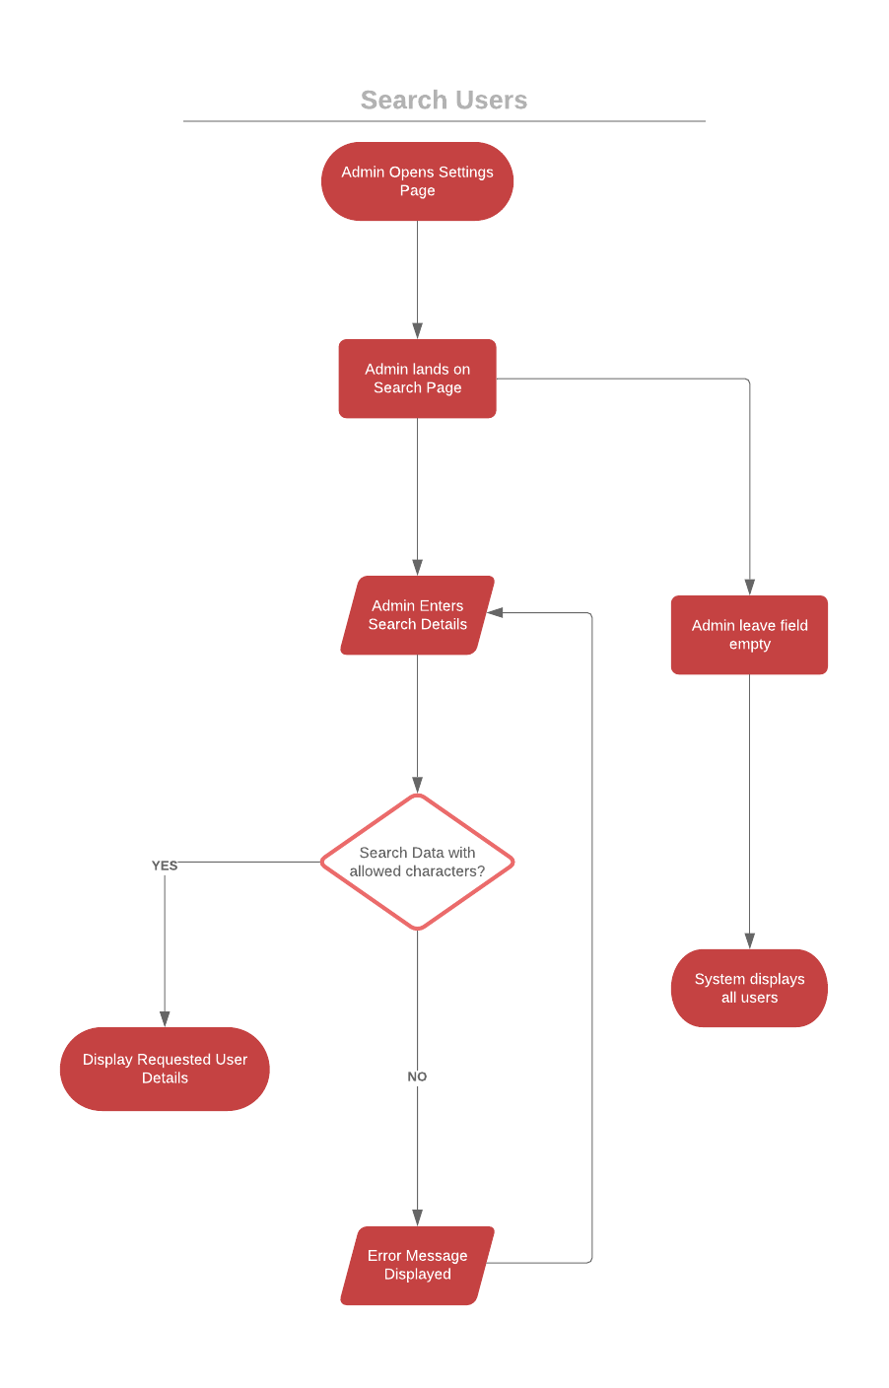

##### Ban User

|  |  |
| --- | --- |
| Login | Ban User |
| Primary actor | Admins |
| Secondary actor | - |
| Pre-condition | Admins should do a user search |
| Trigger | Admins Select (long press) a User from Search results |
| Path | 1. System displays Options Menu 2. Admins Select ‘Ban User’ 3. System blocks the user from system |
| Post-conditions | Admin directed to Search results Page |
| Alternative Path 1 | 1. Admin touches username |
| Alternative Post-conditions | System displays specific user details |
| Alternative Path 2 | 1. Admin bans user who is already banned |
| Alternative Post-conditions | System verifies and displays the user is already banned |

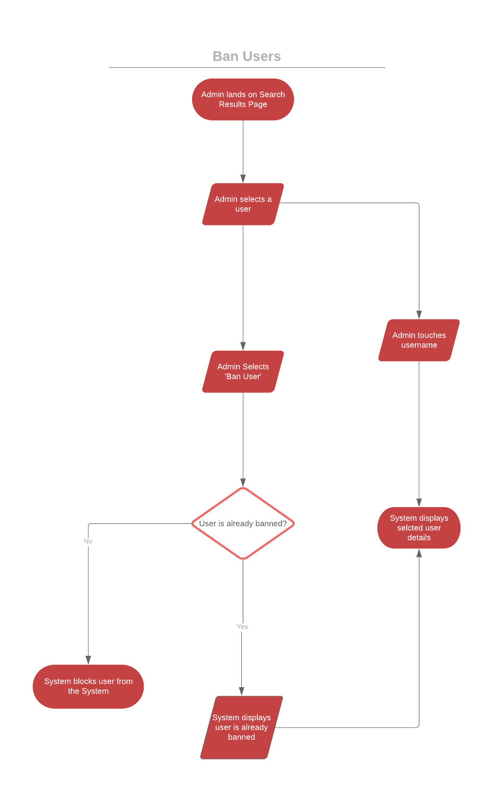

##### Unban User

|  |  |
| --- | --- |
| Login | Unban User |
| Primary actor | Admins |
| Secondary actor | - |
| Pre-condition | Admins should do a user search |
| Trigger | Admins Select (long press) a User from Search results |
| Path | 1. System displays Options Menu 2. Admins Select ‘Unban User’ 3. System unblocks the user from system |
| Post-conditions | Admin directed to Search results Page |
| Alternative Path 1 | 1. Admin touches username |
| Alternative Post-conditions | System displays specific user details |
| Alternative Path 2 | 1. Admin Unbans user who is not banned |
| Alternative Post-conditions | System verifies and displays the user is not banned |

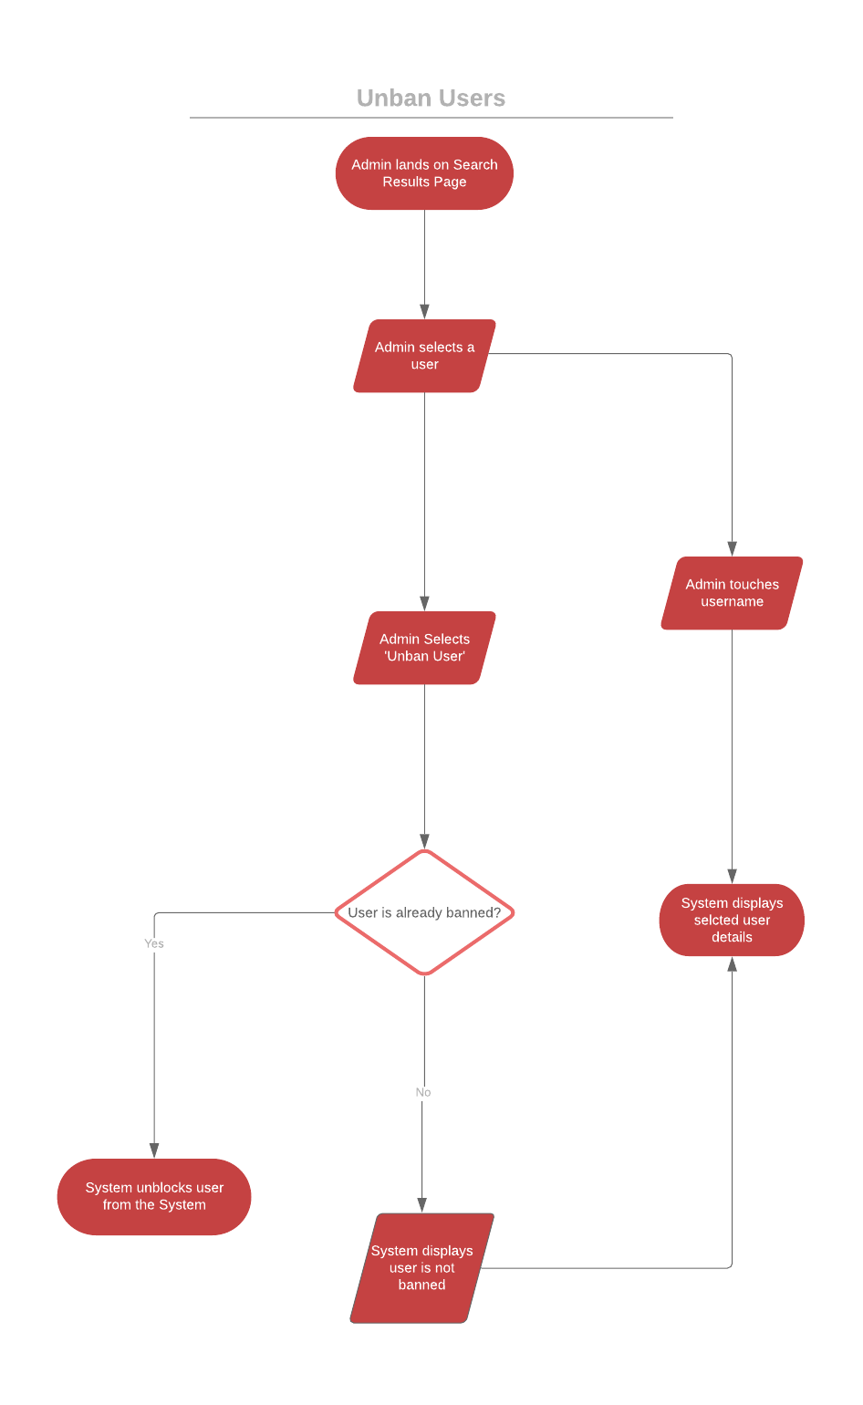

## 5.2 Design - Initial Designs (Wireframe) VS App Design

#### Register

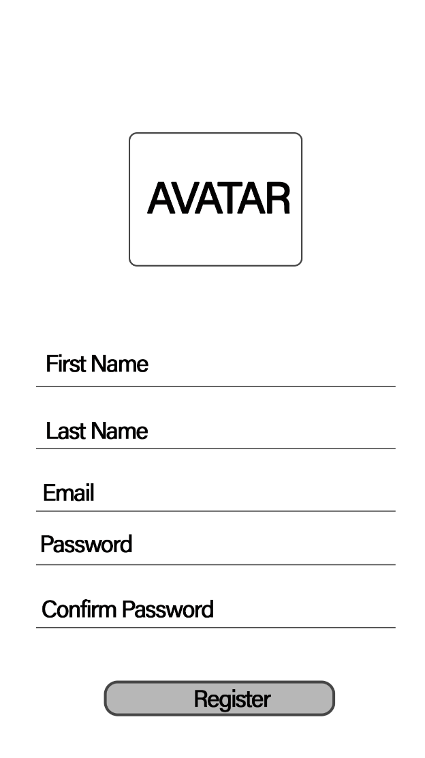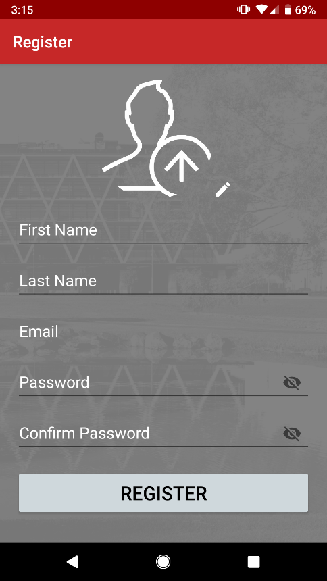

#### Login

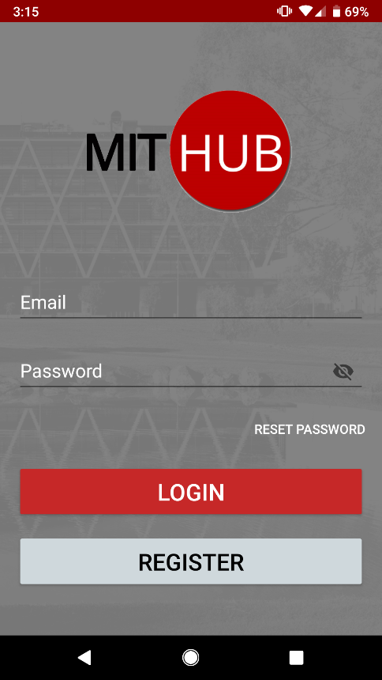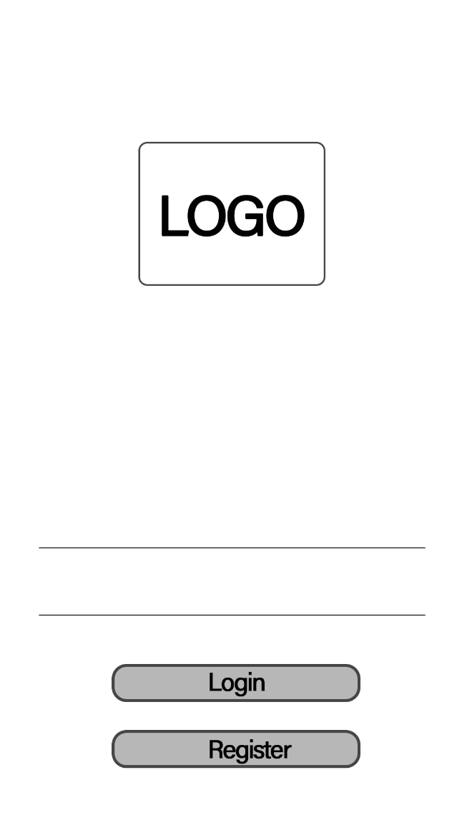

#### Categories

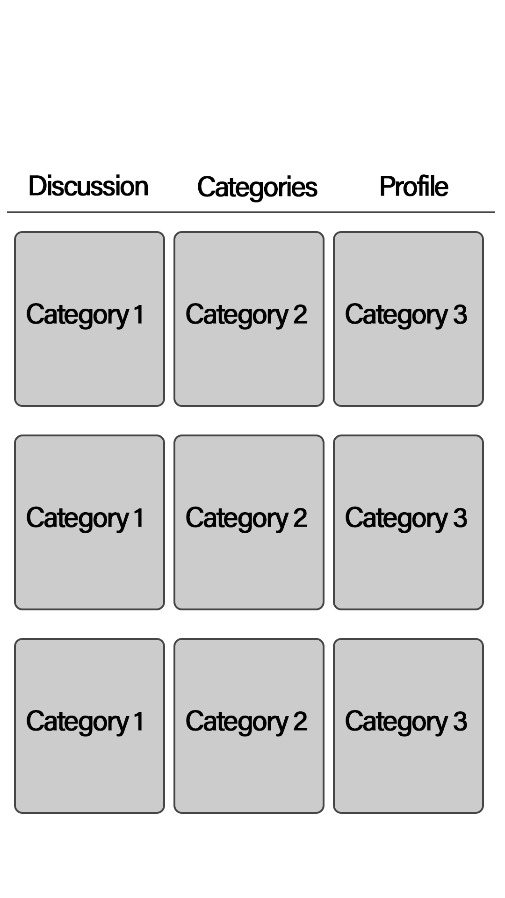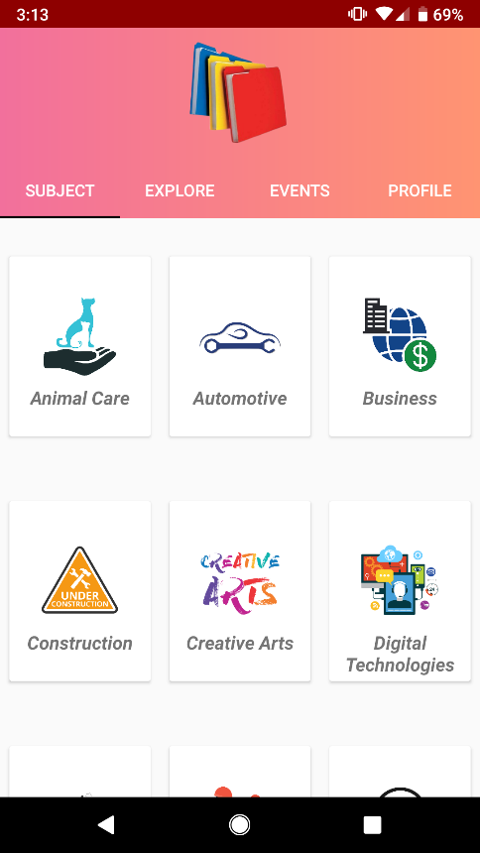

#### Profile

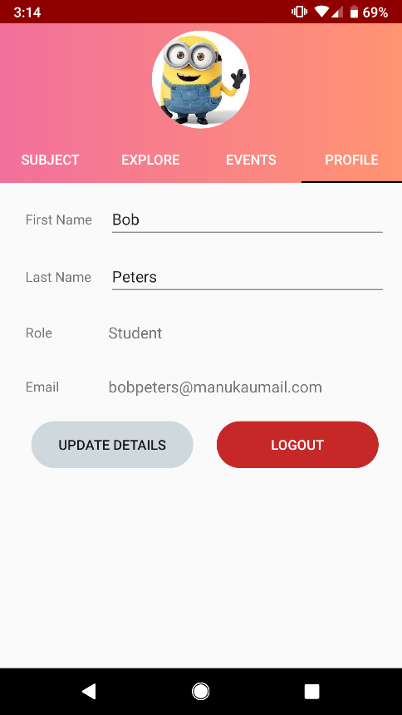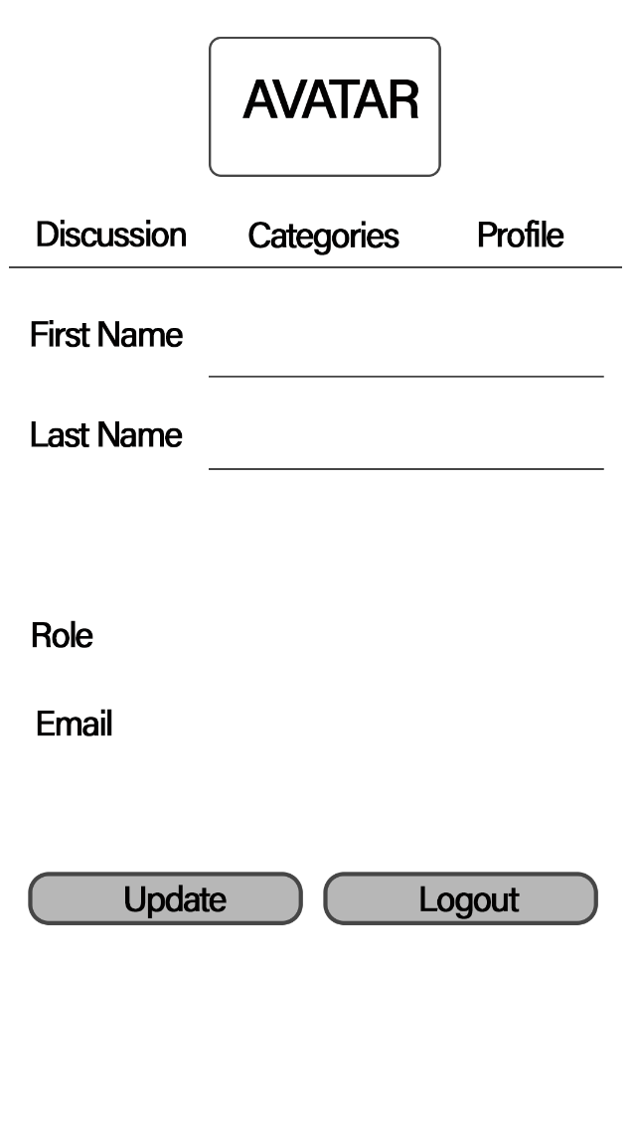

##### Create Discussion

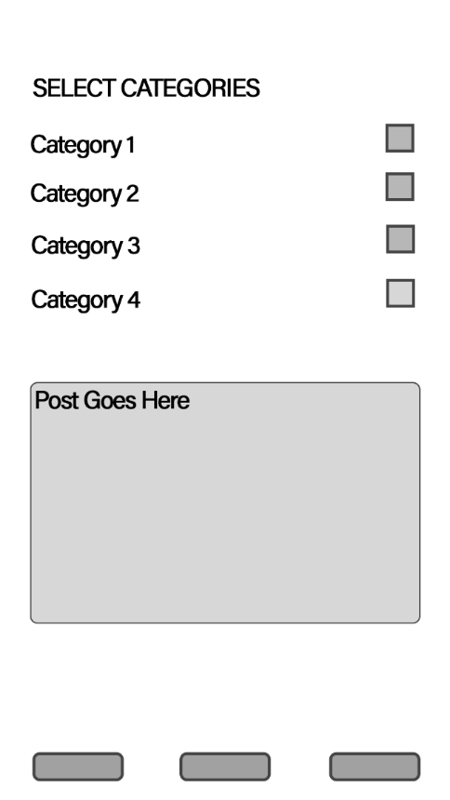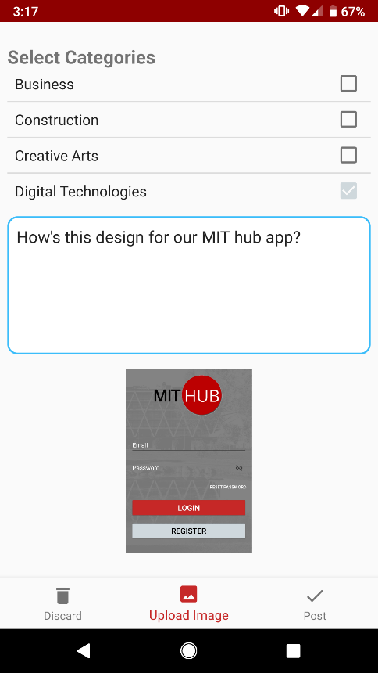

##### View Discussions

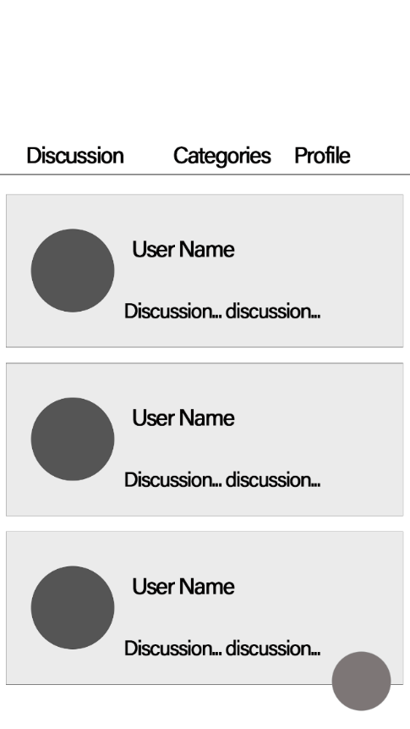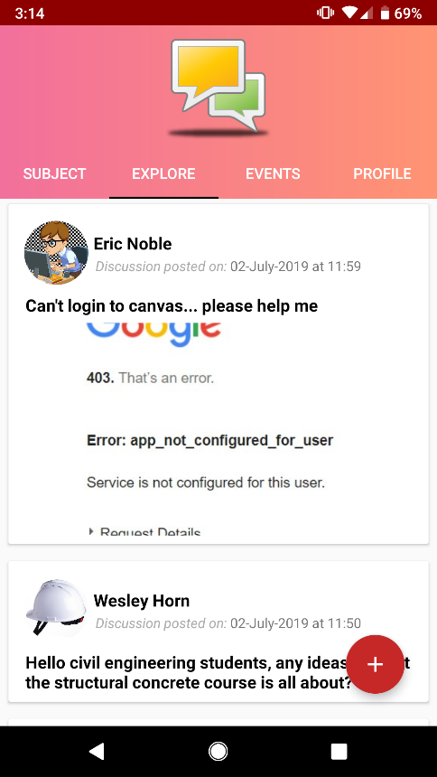

##### View Comments

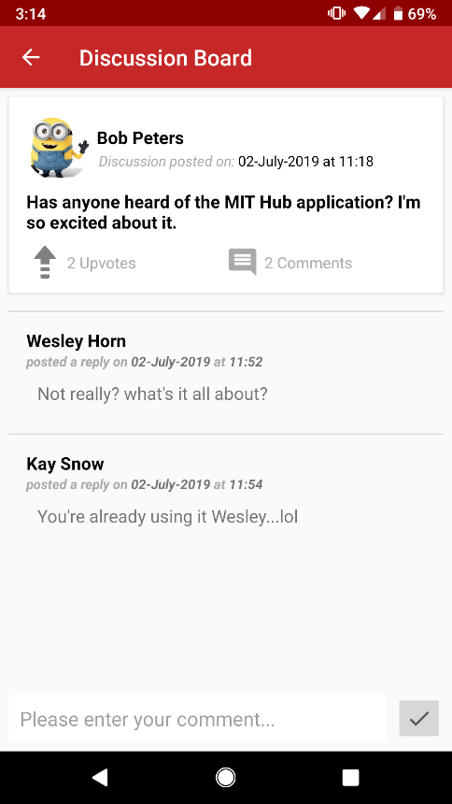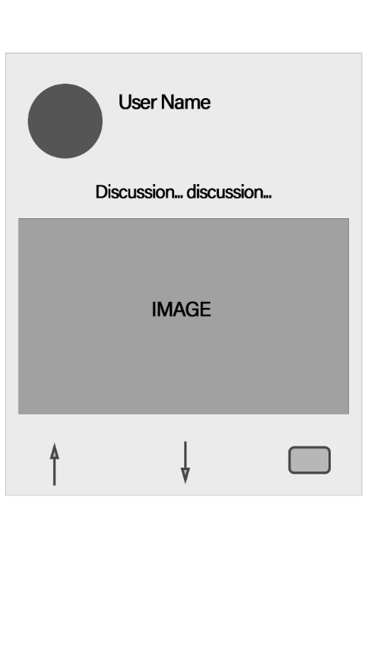

##### Added functionalities and User Interfaces

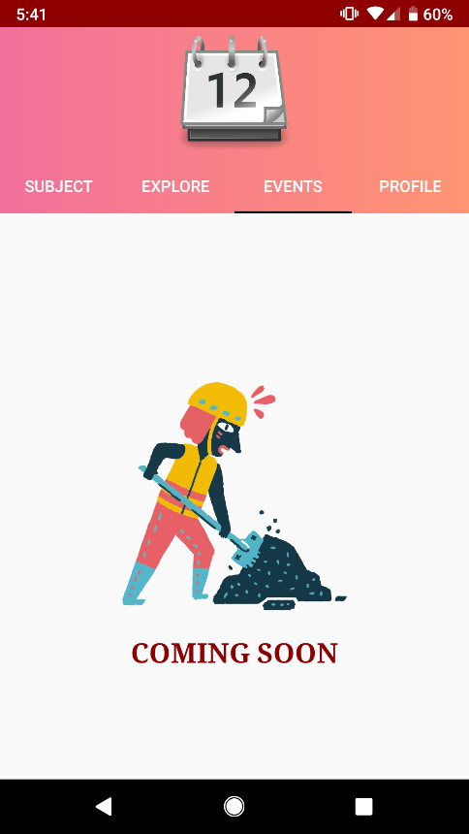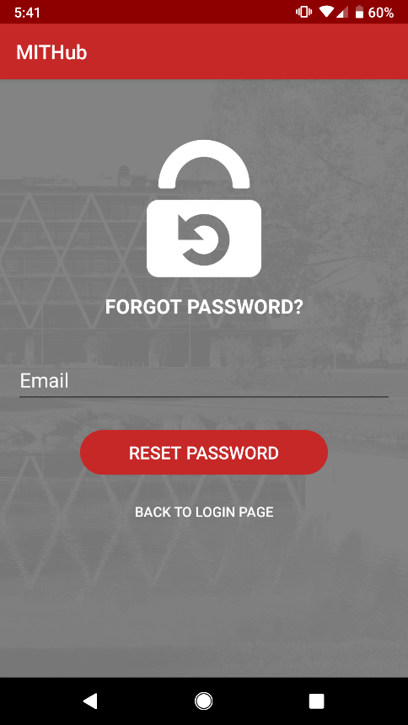

## 5.3 Software Testing

As we had selected the feature driven, agile methodology for our project, testing of the application was done after each feature (functionality) was developed. Adopting this software development framework also meant that we were designing the UI and the apps based on the feature we were developing at that given time. The tables below display the results of our software tests

|  |  |  |  |  |  |
| --- | --- | --- | --- | --- | --- |
| Register | | | | | |
| *Case #* | *Test Case* | *Input* | *Expected Result* | *Actual Result* | *Pass/Fail* |
| 1 | Image upload | User clicks on the photo upload icon | User redirected to the phone gallery to select the image | Phone gallery displayed | Pass |
| 2 | Crop Image | User selects image from gallery | User allowed to crop and resize image | Cropping screen is displayed and user can crop the image | Pass |
| 3 | Crop complete | User clicks on crop button after selecting and cropping an image | Replace the upload photo icon register screen with the selected cropped image | Cropped image displayed on the register screen | Pass |
| 2 | Any empty fields | None | Error message displayed under empty input fields | Text displayed | Pass |
| 3 | Registering with email already existing in the database | Email already in use | Error message "email address is already in use by another account" | Error message displayed | Pass |
| 4 | Profile photo image not selected | None | Error message “please select a photo to identify yourself” | Error message displayed | Pass |
| 5 | User enters password that do not match | User enters different password | Error message “the password you have entered do not match” | Error message displayed | Pass |
| 6 | User enters valid details for registration | All valid inputs | Message “Registration Successful” and user redirected to main screen | Message and home screen are displayed | Pass |

|  |  |  |  |  |  |
| --- | --- | --- | --- | --- | --- |
| Login | | | | | |
| *Case #* | *Test Case* | *Input* | *Expected Result* | *Actual Result* | *Pass/Fail* |
| 1 | Empty input fields | None | Text displayed under the input field left empty advising user to enter the missing details | Text displayed | Pass |
| 2 | Invalid username or password | Username or password not in the firebase database | Error message saying invalid username or password | Error message displayed | Pass |
| 3 | Valid username and password | User enters matching username and password | User redirected to main screen that displays the discussion categories | Home screen displayed | Pass |

|  |  |  |  |  |  |
| --- | --- | --- | --- | --- | --- |
| Update Personal Details | | | | | |
| *Test Case #* | *Test Case* | *Input* | *Expected Output* | *Actual Output* | *Pass/Fail* |
| 1 | Profile fragment selected | User swipes to the profile fragment/clicks on the profile header | Display all personal details in their relevant fields | All personal details displayed | Pass |
| 2 | Profile fragment selected | User swipes to the profile fragment/clicks on the profile header | Display user profile photo above the navbar | User profile image is displayed | Pass |
| 3 | User tries to update details with empty fields | None | Error message “please enter missing details” | Error message displayed | Pass |
| 4 | Logout button | User clicks on the logout button | User should be logged out and redirected to the login screen | User redirected to the login screen | Pass |
| 5 | Re-open application after logging out | User clicks on the logout button, closes the app and re-opens it | Login screen should be displayed instead of the home screen | Login screen displayed when app is opened | Pass |

|  |  |  |  |  |  |
| --- | --- | --- | --- | --- | --- |
| View Categories | | | | | |
| *Case #* | *Test Case* | *Input* | *Expected Result* | *Actual Result* | *Pass/Fail* |
| 1 | Category Button Clicked | User clicks on any one of the categories | Display a list of the discussions that are categorised under the one selected. (Latest discussions to be displayed at the top) | List of discussions displayed in the right order (latest first) | Pass |

|  |  |  |  |  |  |
| --- | --- | --- | --- | --- | --- |
| Post Discussion | | | | | |
| *Test Case #* | *Test Case* | *Input* | *Expected Output* | *Actual Output* | *Pass/Fail* |
| 1 | Discard button | User clicks on discard button | Redirect to home screen | User redirected to home screen | Pass |
| 2 | Upload image button | User click on the upload image button | Display phone gallery | Phone gallery is displayed allowing user to select an image | Pass |
| 3 | Crop Image | User selects an image from the phone gallery | Display cropping screen | Image is displayed on the screen along with the cropping tools | Pass |
| 4 | Crop complete | User clicks on crop button after cropping the image | Redirect to post discussion screen and display the cropped image | User redirected to post discussion screen with the cropped image displayed on the screen | Pass |
| 5 | No categories selected | User clicks on post without selecting a category for discussion | Error message “Please select a category” | Error message displayed | Pass |
| 6 | No discussion message | User clicks on post without entering discussion message | Error “Please enter discussion message” | Error message displayed | Pass |
| 7 | Discussion message entered and at least one category selected | User clicks on post with all valid inputs | Discussion saved to database, redirect to discussions screen | Discussion saved and user redirected to discussions screen displaying all latest posts | Pass |

|  |  |  |  |  |  |
| --- | --- | --- | --- | --- | --- |
| View Discussions | | | | | |
| *Case #* | *Test Case* | *Input* | *Expected Result* | *Actual Result* | *Pass/Fail* |
| 1 | Discussions fragment selected | User swipes to discussions category/clicks on the discussion’s header | Display all discussions (latest first) and change navbar icon | List of discussions displayed in the expected order and navbar icon changes to a discussions bubble | Pass |
| 2 | Post discussion button | User clicks on the “+” floating button on the screen | Redirect to post discussion screen | User redirected to the post discussion activity | Pass |

|  |  |  |  |  |  |
| --- | --- | --- | --- | --- | --- |
| View Replies to Discussion | | | | | |
| *Test Case #* | *Test Case* | *Input* | *Expected Output* | *Actual Output* | *Pass/Fail* |
| 1 | View Replies | User clicks on a discussion from the discussions list | Redirect user to discussion board where all the comments are displayed | User redirected to discussion board | Partly (use is redirected to wrong discussion board at times) |

|  |  |  |  |  |  |
| --- | --- | --- | --- | --- | --- |
| Reply to a discussion | | | | | |
| *Test Case #* | *Test Case* | *Input* | *Expected Output* | *Actual Output* | *Pass/Fail* |
| 1 | Empty reply | None | Error message “please enter a message comment to submit” | Error message displayed | Pass |

|  |  |  |  |  |  |
| --- | --- | --- | --- | --- | --- |
| Upvote/Downvote discussion | | | | | |
| *Test Case #* | *Test Case* | *Input* | *Expected Output* | *Actual Output* | *Pass/Fail* |
| 1 | Upvote discussion | User clicks on the upvote icon | Increase number of upvotes by 1, change the icon to a downvote icon and change the votes counter text to green | The voting icon changes, number of upvotes increases by 1 and text colour changes | Pass |
| 2 | Downvote discussion | User clicks on the downvote icon | Number of upvotes reduced by 1, icon changes back to up arrow and text is restored to grey | Upvotes counter colour changed, reduced by 1 and icon altered | Pass |

## 5.4 Project Analysis & Learning Curve

Having a limited time for the project and having only one developer in the team meant that we could not fully develop all the functionalities of our application. We could not complete the administrator functionalities, to be more specific the search user, ban and unban user functionalities. However, we did manage to fully build all the other features that we had identified earlier for the main user of our application, the students.

This has been on of the best courses I have studied at MIT as the knowledge and experience I have gained doing this project is immeasurable and invaluable. During the development of this application, Angelo and I had come up with so many other ideas that would help improve our application. However, due to time constraints we could not implement these to our application.

Some of these ideas that could be implemented to the future development of our application include, ridesharing, flatting, posting and viewing events, job hunting and advertising as well as some of the functionalities that we could not achieve such as the administrator functionalities.

# Conclusion

As per our plan to create a better communication platform for MIT students, we have successfully created the MIT Hub, an android application that will act as a communication hub for all the students at MIT.

From the beginning of our journey till the end, we went through a complete software development lifecycle with a proper project management methodology to practise a real-world scenario and succeeded.

We did start with requirement gathering based on the existing product (at the time) where was MIT Canvas along with all other similar apps around the world that was created for the same purpose, we wanted to create the App. Based on the gathered requirements and functionalities we learnt from similar app we thought will add value, we created MIT Hub successfully.

Although the App is fully functional to the expected functionalities, there are many more functionalities that can be added to make the app even more resourceful but due to the limited time constraints, we have left those functionalities for future development plans.

# Appendices

## Appendix A

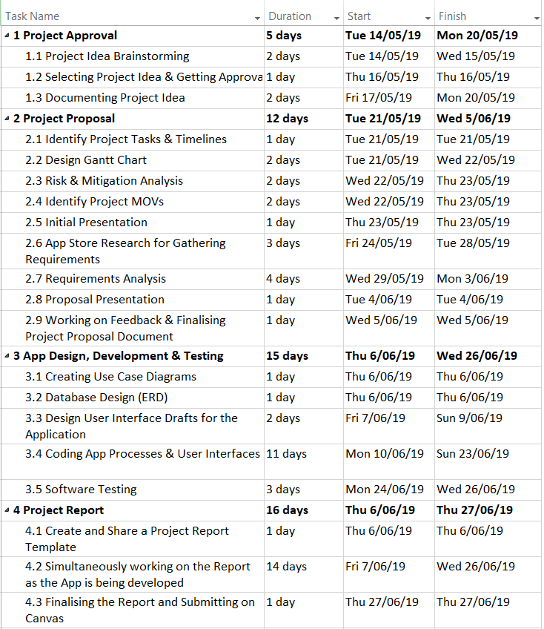

### Meeting Minutes

#### Meeting 1

**Minutes of Meeting #1** *16/05/2019 in MIT Manukau at 11am*

**Chairperson:**  Angelo Coonghe

**Minute Taker:** Sanket Hirani

**Present:**  Angelo, Sanket

|  |  |  |  |
| --- | --- | --- | --- |
| **Agenda**  **Item** | **Description *– include a heading for each item recorded and a brief summary of the discussion.*** | ***Responsible*** | ***Date to be Completed*** |
| 1. | **Appointment of chairperson and recorder**  *Angelo* was appointed to chair the meeting and *Sanket* was appointed to take minutes of this meeting. |  |  |
| 2. | **Meeting Discussions**   * Sharing ideas for the project * Selecting the best idea, sharing it with the lecturer and got approval with a few changes suggested * Filling up the one-page idea proposal document by responding to several questions related to the proposal idea such as:   + The opportunity of the proposal   + Scope of the project   + Aims & objectives of the project   + The software methodology that will be used |  |  |
| 3 | **Task allocation** |  |  |
| **3.1** Fill in the answers to the first half of the proposal document questions based on the discussions held during the meeting. | Angelo | 19/05/19 |
| **3.2** Fill in the rest of the document and submit it to canvas | Sanket | 20/05/19 |
| 4 | Date and time of next meeting  21/05/19 at 2pm |  |  |
| 5 | Close meeting: 16/05/19 at 1.30pm |  |  |

#### Meeting 2

**Minutes of Meeting #2** *21/05/19 at 2pm*

**Chairperson:**  Angelo Coonghe

**Minute Taker:** Sanket Hirani

**Present:**  Angelo, Sanket

|  |  |  |  |
| --- | --- | --- | --- |
| **Agenda**  **Item** | **Description *– include a heading for each item recorded and a brief summary of the discussion.*** | ***Responsible*** | ***Date to be Completed*** |
| 1. | **Appointment of chairperson and recorder**  *Angelo* was appointed to chair the meeting and *Sanket* was appointed to take minutes of this meeting. |  |  |
| 2. | **Review of previous minutes and actions**  All members completed the work they were given, and the file was submitted to canvas. |  |  |
| 3. | **Meeting Discussions**   * Preparation for the initial presentation; contents of the presentation, who will be presenting what. * Breakdown of the project tasks to know what needs to be done by when as well as have the details ready for the Gantt chart. |  |  |
| 4. | **Task allocation** |  |  |
| **4.1** Identify project MOVs, project scope, added values and areas of impact and add this to the shared slide on google drive | **Angelo** | 23/05/19 by 11am |
| **4.2** Add a slide for project aims and objectives, Design the Gantt chart, identify project risks and possible ways to reduce the risks. Make final design changes to the presentation. | **Sanket** | 23/05/19 by 11am |
| **4.3** Search for design and functionality inspiration for our project by having a look and feel of other similar mobile applications | **Sanket, Angelo** | 28/05/19 |
| 5. | Date and time of next meeting: 28/05/19 at 2pm |  |  |
| 6. | Close meeting: 21/05/19 at 4.45pm |  |  |

#### Meeting 3

**Minutes of Meeting #3** *28/05/19 at 12pm*

**Chairperson:**  Angelo Coonghe

**Minute Taker:** Sanket Hirani

**Present:**  Angelo, Sanket

|  |  |  |  |
| --- | --- | --- | --- |
| **Agenda**  **Item** | **Description *– include a heading for each item recorded and a brief summary of the discussion.*** | ***Responsible*** | ***Date to be Completed*** |
| 1. | **Appointment of chairperson and recorder**  *Angelo* was appointed to chair the meeting and *Sanket* was appointed to take minutes of this meeting. |  |  |
| 2. | **Review of previous minutes and actions**  Presentation was a success and received a few key tips from the lecturers on what to do next. |  |  |
| 3. | **Meeting Discussions**   * The content of the project proposal document. * Once the content was identified and listed down, we equally distributed the work and we then started working on the proposal report. |  |  |
| 4. | **Task allocation** |  |  |
| **4.1** Report introduction, literature review (3 apps, the app comparison table and the literature review summary), requirements collection and analysis and the application design and analysis. | **Angelo** | 02/06/19 |
| **4.2** Project MOV, aims and objectives, the research question, literature review (2 apps) software methodology used and risks and mitigation analysis | **Sanket** | 04/06/19 |
| 5. | Date and time of next meeting: 30/05/19 at 11am |  |  |
| 6. | Close meeting: 28/05/19 at 1pm |  |  |

#### Meeting 4

**Minutes of Meeting #4** *30/05/19 at 11am*

**Chairperson:**  Angelo Coonghe

**Minute Taker:** Sanket Hirani

**Present:**  Angelo, Sanket

|  |  |  |  |
| --- | --- | --- | --- |
| **Agenda**  **Item** | **Description *– include a heading for each item recorded and a brief summary of the discussion.*** | ***Responsible*** | ***Date to be Completed*** |
| 1. | **Appointment of chairperson and recorder**  *Angelo* was appointed to chair the meeting and *Sanket* was appointed to take minutes of this meeting. |  |  |
| 2. | **Review of previous minutes and actions**  Progress on the report is great, expected to be finished by the due date, Tuesday 04/6/19 at 4pm |  |  |
| 3. | **Meeting Discussions**   * Discussion on missing and any additional content that could be added to the proposal report. * Who is doing what, distribution of work on the proposal report not discussed earlier. * Angelo must complete the work by Sunday giving me enough time to properly format the document and submit the report. |  |  |
| 4. | **Task allocation** |  |  |
| **4.1** Resources and technologies used for the report and draft designs for a couple of screens of the application. | **Angelo** | 02/06/19 |
| **4.2** Report summary and work breakdown structure. Submitting the report. | **Sanket** | 04/06/19 |
| 5. | Date and time of next meeting: 04/06/19 at 2pm |  |  |
| 6. | Close meeting: 30/05/19 at 1.30pm |  |  |

#### Meeting 5

**Minutes of Meeting #5** *04/06/19 at 2pm*

**Chairperson:**  Angelo Coonghe

**Minute Taker:** Sanket Hirani

**Present:**  Angelo, Sanket

|  |  |  |  |
| --- | --- | --- | --- |
| **Agenda**  **Item** | **Description *– include a heading for each item recorded and a brief summary of the discussion.*** | ***Responsible*** | ***Date to be Completed*** |
| 1. | **Appointment of chairperson and recorder**  *Angelo* was appointed to chair the meeting and *Sanket* was appointed to take minutes of this meeting. |  |  |
| 2. | **Review of previous minutes and actions**  Proofread the proposal report and looks all set for submission |  |  |
| 3. | **Meeting Discussions**   * Preparation for the presentation begins. Discussed what slides to remove from the initial presentation and what to include in the upcoming one. * Who is going to present what and order of presentation? * Started creating a shared UML use case diagram on *lucidchart.com* to start the design phase of the project implementation part. |  |  |
| 4. | **Task allocation** |  |  |
| **4.1** Prepare slides for the literature review, draft designs and the use case diagram. Also work on the use case diagram. | **Angelo** | 05/06/19 |
| **4.2** Modify the slides on project description, objectives, scope and risks. Add a slide for project methodology and do some work on the use case diagram. | **Sanket** | 06/06/19 |
| 5. | Date and time of next meeting: 06/06/19 at 2pm |  |  |
| 6. | Close meeting: 04/06/19 at 4.30pm |  |  |

#### Meeting 6

**Minutes of Meeting #6** *06/06/19 at 2pm*

**Chairperson:**  Angelo Coonghe

**Minute Taker:** Sanket Hirani

**Present:**  Angelo, Sanket

|  |  |  |  |
| --- | --- | --- | --- |
| **Agenda**  **Item** | **Description *– include a heading for each item recorded and a brief summary of the discussion.*** | ***Responsible*** | ***Date to be Completed*** |
| 1. | **Appointment of chairperson and recorder**  *Angelo* was appointed to chair the meeting and *Sanket* was appointed to take minutes of this meeting. |  |  |
| 2. | **Review of previous minutes and actions**  Our presentation was scheduled for Tuesday the 11th of June, this meant that we had extra time and could add some extra stuff to the presentation. |  |  |
| 3. | **Meeting Discussions**   * Reviewed the use case diagram and made the necessary changes. * Decided to make a few tweaks to our presentation slides after learning a few things from the presentation that had been done. |  |  |
| 4. | **Task allocation** |  |  |
| **4.1** Start working on the use case description tables for all the use cases in our use case diagram. | **Angelo** | 05/06/19 |
| **4.2** Research on how firebase works with android apps as this is going to be our database server for the application and it is something that I, as the developer have never worked with | **Sanket** | 06/06/19 |
| 5. | Date and time of next meeting: 11/06/19 at 2pm |  |  |
| 6. | Close meeting: 06/06/19 at 2.30pm |  |  |

#### Meeting 7

**Minutes of Meeting # 7** 11/06/2019 at 2pm

**Chairperson:**  Sanket Hirani

**Minute Taker:** Angelo Coonghe

**Present:**  Angelo, Sanket

|  |  |  |  |
| --- | --- | --- | --- |
| **Agenda**  **Item** | **Description *– include a heading for each item recorded and a brief summary of the discussion.*** | ***Responsible*** | ***Date to be Completed*** |
| 1. | **Appointment of chairperson and recorder**  *Sanket* was appointed to chair the meeting and *Angelo* was appointed to take minutes of this meeting. |  |  |
| 2. | **Review of previous minutes and actions**  Worked on fine tuning the presentation along with updated use case diagrams and last-minute changes to the presentation. |  |  |
| 3. | **Meeting Discussions**   * Reviewed the use case descriptions and discussed about the flowcharts and wireframe designs. * Presented the presentation and got feedback from Fadi |  |  |
| 4. | **Task allocation** |  |  |
| **4.1** Start working on Flowcharts and finish the initial design phase | **Angelo** | 18/06/2019 |
| **4.2** Sanket to work on initial designs with coding while Angelo work on documentation | **Sanket & Angelo** | 18/06/2019 |
| 5. | Date and time of next meeting: 18/06/2019 |  |  |
| 6. | Close meeting: 11/06/2019 at 4.30pm |  |  |

#### Meeting 8

**Minutes of Meeting # 8** 18/06/2019 at 2pm

**Chairperson:**  Sanket Hirani

**Minute Taker:** Angelo Coonghe

**Present:**  Angelo, Sanket

|  |  |  |  |
| --- | --- | --- | --- |
| **Agenda**  **Item** | **Description *– include a heading for each item recorded and a brief summary of the discussion.*** | ***Responsible*** | ***Date to be Completed*** |
| 1. | **Appointment of chairperson and recorder**  *Sanket* was appointed to chair the meeting and *Angelo* was appointed to take minutes of this meeting. |  |  |
| 2. | **Review of previous minutes and actions**  Completed all the use case descriptions and flowcharts and started working on final documentation. |  |  |
| 3. | **Meeting Discussions**   * Reviewed the flowcharts and finalized all the diagrams. * discussed design and started working on the design |  |  |
| 4. | **Task allocation** |  |  |
| **4.1** Complete all the icons for the App and work on documentation | **Angelo** | 22/06/2019 |
| **4.2** To complete initial functionalities and work on final coding | **Sanket & Angelo** | 23/06/2019 |
| 5. | Date and time of next meeting: 25/06/2019 |  |  |
| 6. | Close meeting: 18/06/2019 at 2.30pm |  |  |

#### Meeting 9

**Minutes of Meeting # 9** 25/06/2019 at 2pm

**Chairperson:**  Sanket Hirani

**Minute Taker:** Angelo Coonghe

**Present:**  Angelo, Sanket

|  |  |  |  |
| --- | --- | --- | --- |
| **Agenda**  **Item** | **Description *– include a heading for each item recorded and a brief summary of the discussion.*** | ***Responsible*** | ***Date to be Completed*** |
| 1. | **Appointment of chairperson and recorder**  *Sanket* was appointed to chair the meeting and *Angelo* was appointed to take minutes of this meeting. |  |  |
| 2. | **Review of previous minutes and actions**  Completed all the use case descriptions and flowcharts and started working on final documentation. |  |  |
| 3. | **Meeting Discussions**   * Review the app design and errors. * Discuss final stage of app completion and demo |  |  |
| 4. | **Task allocation** |  |  |
| **4.1** Complete the final report | **Angelo** | 26/06/2019 |
| **4.2** To complete final app configuration and prepare demo | **Sanket & Angelo** | 27/06/2019 |
| 5. | Date and time of next meeting: -- |  |  |
| 6. | Close meeting: 25/06/2019 at 2.30pm |  |  |

# References

Alexandra, J. (2018, February 09). *Measurable Organizational Value*. Retrieved from Binus University School of information Systems: https://sis.binus.ac.id/2018/02/09/measurable-organizational-value-mov/

Brainyoo Mobile Learning GmbH. (2019, May 13). BRAINYOO Flashcard App (2.8.7) [Mobile Application Software]. *BRAINYOO Flashcard App*. Retrieved May 30, 2019, from https://play.google.com/store/apps/details?id=com.brainyoo.brainyoo2

Harvey, R. (2012, March 9). *Is the Waterfall software development methodology still viable?* Retrieved from Stack Exchange: https://softwareengineering.stackexchange.com/questions/139013/is-the-waterfall-software-development-methodology-still-viable

Manukau Institute of Technology. (2018). *Manukau Institute of Technology Annual Report 2018.* Manukau Institute of Technology, Auckland. Retrieved May 29, 2019, from https://www.manukau.ac.nz/__data/assets/pdf_file/0011/427295/MIT-2018-Annual-Report.pdf

Manukau Institute of Technology. (2018). *Plans and Strategies*. Retrieved May 30, 2019, from Manukau Institute of Technology Website: https://www.manukau.ac.nz/about/about-the-institute/plans-and-strategies

Manukau Institute of Technology. (n.d.). *Areas of Study*. Retrieved May 29, 2019, from Manukau Institute of Technology Website: https://www.manukau.ac.nz/study/areas-of-study

Manukau Institute of Technology. (n.d.). *Student Life*. Retrieved May 29, 2019, from Manukau Institute of Technology website: https://www.manukau.ac.nz/student-life

National American University. (2018, August 9). National American University (1.2) [Mobile Application Software]. *National American University*. Retrieved May 30, 2019, from https://play.google.com/store/apps/details?id=edu.national.dist

New Zealand Qualifications Authority. (n.d.). *Manukau Institute of Technology provider details*. Retrieved May 29, 2019, from NZQA Website: https://www.nzqa.govt.nz/providers/details.do?providerId=601047001

Studydrive GmbH. (2019, May 14). Studydrive GmbH (2.76) [Mobile Application Software]. *Studydrive GmbH*. Retrieved May 30, 2019, from https://play.google.com/store/apps/details?id=de.veedapp.veed&hl=en_US

StudySmarter. (2019, May 23). StudySmarter - Your learning app for university (1.2.0) [Mobile Application Software]. *StudySmarter - Your learning app for university*. Retrieved May 30, 2019, from https://play.google.com/store/apps/details?id=com.studysmarter

The American University in Cairo. (2019, May 23). AUC Mobile (1.3.1) [Mobile Application Software]. *AUC Mobile*. Retrieved May 30, 2019, from https://play.google.com/store/apps/details?id=auc.edu

Wikipedia. (2019, May 28). *Android Studio* . Retrieved from Wikipedia, the free encyclopedia: https://en.wikipedia.org/wiki/Android_Studio

Wikipedia. (2019, April 2). *Work breakdown structure*. Retrieved from Wikipedia, the free encyclopedia: https://en.wikipedia.org/wiki/Work_breakdown_structure

Zulqadar, A. (2019, February 12). *SDLC Waterfall Model*. Retrieved from Rezaid Web Site: https://rezaid.co.uk/sdlc-waterfall-model/